Q.I Read the clues and write the answers in the crossword. /6

1. Do this with water and soap to keep healthy.
2. Your skin does this when it gets hot.
3. These are things that can make you sick.
4. Do this everyday to keep your heart and other muscles healthy.
5. If you have one of these, you could feel sick.
6. This word means the food a person eats.

|  |  |  |
| --- | --- | --- |
| diet | sweat | Wash |
| Illness | exercise | germs |

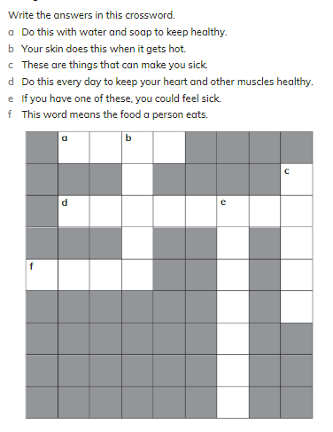

____________________________________________________________

II. Draw a line to match what each does. /4

a) molar i) strong teeth

b) incisor ii) biting food

c) canine iii) chewing and grinding food

d) toothpaste iv) tearing food

_____________________________________________________________