**I) TASK A: Find some facts about rain forest [10]**

# 

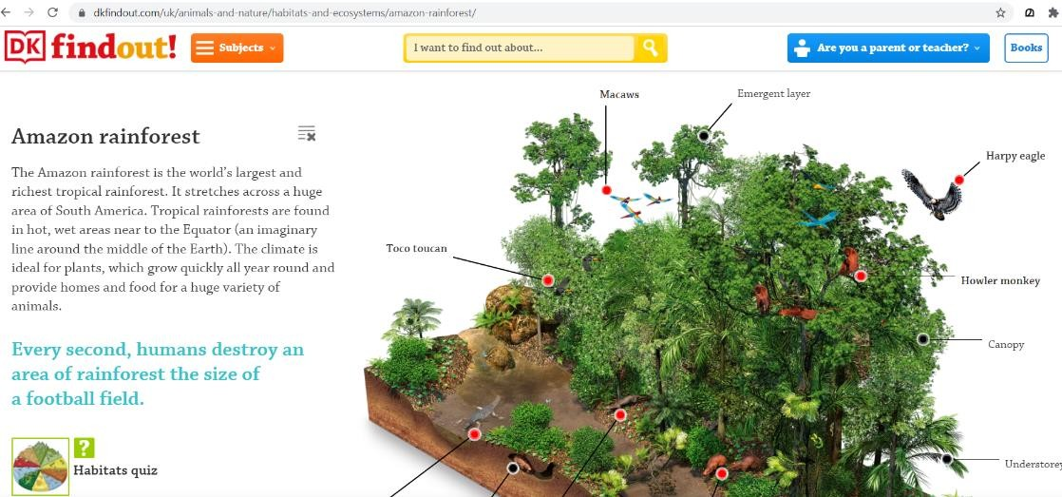

[**https://www.rainforest-alliance.org/everyday-actions/9-rainforest-facts-everyone-should-know/M**](https://www.rainforest-alliance.org/everyday-actions/9-rainforest-facts-everyone-should-know/M)

1. Open **Kiddle** search engine. **/2**

2. In the search box type “rain forest” and find some facts about rain forests **/3**  3. Find about animals in rain forest: **/5**

# **Use a hyperlink**

* + - **Use forward and backward icons**

|  |  |  |  |
| --- | --- | --- | --- |
| Rubric for Find some facts about rainforest | | | |
|  | 1 | 2 | 3 |
| Opening kiddle search engine. |  |  |  |
| Typing and searching “rain forest” in the search box. |  |  |  |
| Identifying and opening proper hyperlink. |  |  |  |
| Using forward and backward icons. |  |  |  |

# **II) TASK B: Simple web search on ‘I get to know the Oryx in my home country, Qatar’. [5]**

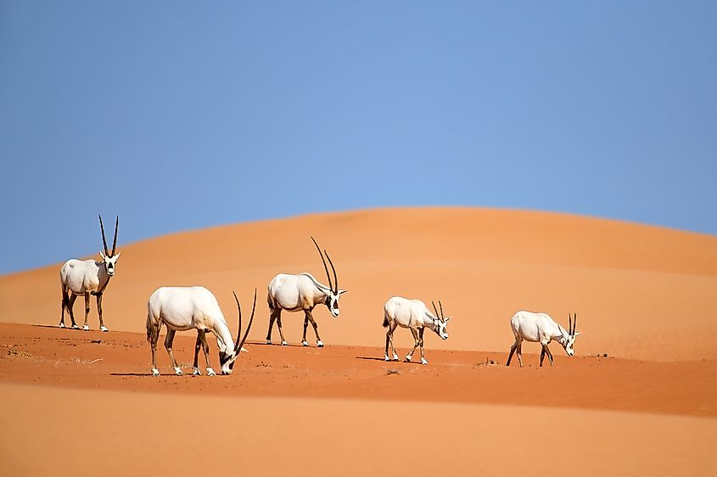

Search the picture of ‘’

Step 1: Open **kiddle** search engine. **/1**

Step 2: Click on the image tab on the search menu. **/2**

Step 3: Type the keyword ‘**Oryx Qatar’** in the search box. **/2**

|  |  |  |  |
| --- | --- | --- | --- |
| Rubric for Search and save the picture | | | |
|  | 1 | 2 | 3 |
| Opening kiddle search engine. |  |  |  |
| Typing and searching picture of ‘Oryx Qatar’ in the search box. |  |  |  |