**Mixing materials**

**Unit 2.5 Separating Materials from Rocks**

**Answer the following:**

1. What is an ore? Name three materials that are made from oil.

An ore is a rock that has metal in it.

Plastic, petrol and diesel are made from oil

1. Why can burning fuels cause a problem?

Burning fuels can make carbon dioxide which causes global warming

1. What is bioplastic? Why is bioplastic created?

Bioplastics are a type of plastic that can be made from natural resources such as vegetable oils and starches

To reduce the problem of plastic waste that is suffocating the planet and contaminating the environment.

1. Imagine you are building a new playground at school. Why might it be important to use metals like steel or aluminum for the swings and slides instead of materials like wood or plastic?



It's important to use metals like steel or aluminum for playground equipment because they are strong and durable. When kids play on swings and slides, they put a lot of weight on them, so we need materials that won't break easily. Metals can also withstand different weather conditions like rain and sun without getting damaged, which makes them great for outdoor use.

1. You are going on a road trip with your family. Explain why the car needs petrol (gasoline) to run and how it helps the car move.



The car needs petrol (gasoline) to run because it's like food for the car's engine. When we put petrol in the car, it mixes with air and gets ignited by a spark, which creates power. This power makes the engine work, so the car can move forward. Without petrol, the car wouldn't be able to go anywhere.

1. During a camping trip, your family uses a gas stove to cook food. How is the gas in the stove similar to and different from the natural gas that we use at home for heating and cooking?

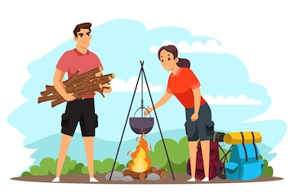

The gas in the camping stove is similar to natural gas because they both come from underground and are used as fuel for cooking. However, the gas in the stove is stored in a small canister, while natural gas at home comes through pipes from underground reservoirs. Both gases burn cleanly and efficiently, making them good choices for cooking.