**Mixing materials**

**Unit 2.5 Separating Materials from Rocks**

**Answer the following:**

1. What is an ore? Name three materials that are made from oil.

_________________________________________________________________________________

_________________________________________________________________________________

1. Why can burning fuels cause a problem?

_________________________________________________________________________________

_________________________________________________________________________________

1. What is bioplastic? Why is bioplastic created?

_________________________________________________________________________________

_________________________________________________________________________________

1. Imagine you are building a new playground at school. Why might it be important to use metals like steel or aluminum for the swings and slides instead of materials like wood or plastic?

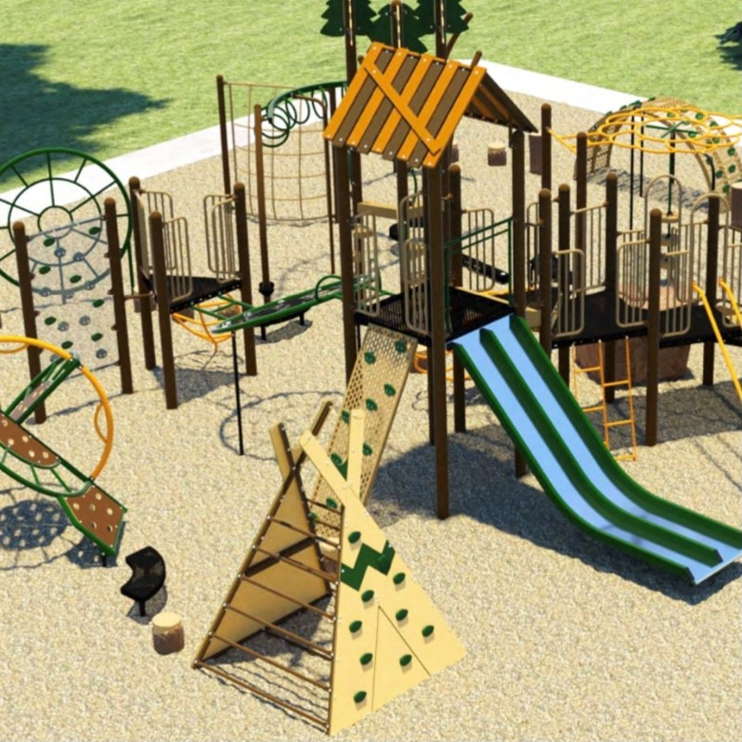

_________________________________________________________________________________

_________________________________________________________________________________

_________________________________________________________________________________

_________________________________________________________________________________

1. You are going on a road trip with your family. Explain why the car needs petrol (gasoline) to run and how it helps the car move.

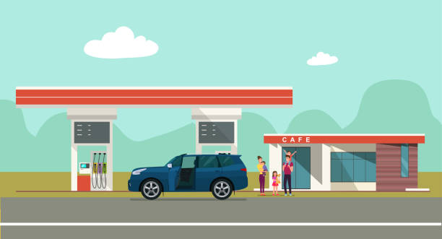

_________________________________________________________________________________

_________________________________________________________________________________

_________________________________________________________________________________

_________________________________________________________________________________

1. During a camping trip, your family uses a gas stove to cook food. How is the gas in the stove similar to and different from the natural gas that we use at home for heating and cooking?









