**Task A: Creating a Game in ScratchJr**

1: Open Scratch on your computer.

2. Create a new project.

3. Add a cat character to your project. here is the algorithm for the **cat**:

|  |  |
| --- | --- |
| **Steps** | **Instruction** |
| 1 | Start on Green Flag |
| 2 | Jump (2) |
| 3 | Jump (3) |
| 4 | Jump (2) |

4. Write down the corresponding code in Scratch.

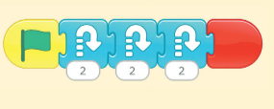

5. Run the program and observe if the code matches the algorithm.

6. Add a dog character to your project. Here is the algorithm for the **Dog:**

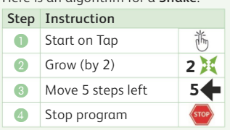 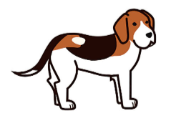

7.Write down the corresponding code in Scratch for **Dog**.



8. Test the code and observe if the program gives the right result.

9. Debug the code if necessary by identifying and fixing any errors.

10. Run the program again to ensure it works correctly.

**Rubric for Practical Worksheet - Task A: Creating a Game in ScratchJr**

| **Criteria** | **Excellent (4)** | **Good (3)** | **Fair (2)** | **Poor (1)** |
| --- | --- | --- | --- | --- |
| Completion of Tasks | All tasks completed accurately and effectively. | Most tasks completed accurately and effectively. | Some tasks completed accurately and effectively. | Few tasks completed accurately and effectively. |
| Algorithm Implementation | Algorithm implemented precisely with clear correspondence to Scratch code. | Algorithm mostly implemented with some minor deviations in Scratch code. | Algorithm partially implemented with noticeable deviations in Scratch code. | Algorithm implementation lacks clarity and coherence in Scratch code. |
| Code Functionality | Code functions correctly without errors. | Code functions correctly with minor errors. | Code functions partially with significant errors. | Code functions incorrectly or does not function at all. |
| Debugging | Code is effectively debugged with all errors identified and fixed appropriately. | Code is mostly debugged with some errors identified and fixed. | Code is partially debugged with few errors addressed. | Debugging is inadequate with errors left unresolved. |
| Presentation of Work | Neat and organized presentation of Scratch project and corresponding code. | Presentation is generally neat and organized but lacks some clarity. | Presentation is somewhat messy or disorganized. | Presentation is messy and difficult to follow. |