|  |  |  |
| --- | --- | --- |
| Term: I  Session: 2023 – 2024 |  | Name: _______________  Date: _______________ |

**Topic: File size calculation**

**Q1.**

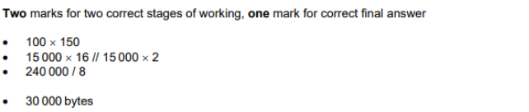

Q2.

