**Berwick swan landing on water**

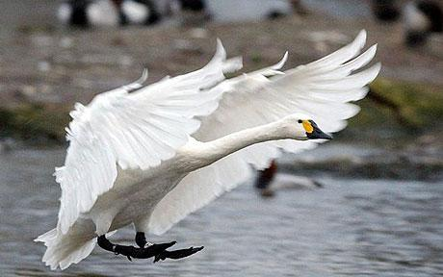

Unit 2 Day 1

**Berwick swan landing on water**



Feet:

Head/eye/beak:

Wing feathers:

Wing:

Neck:

Week 1

Unit 2 Day 1

The Swan

*Soft warm wings, gliding into land*

*Snow-white velvety feathers, stylishly on show*

*Long elegant neck, guiding this powerful airship*

*Night-black feet, to steady and propel*

*Delicate, piercing eyes, focused and calm*

*From flight to sailing yacht, the graceful swan transforms*

*Highlight the nouns in blue*

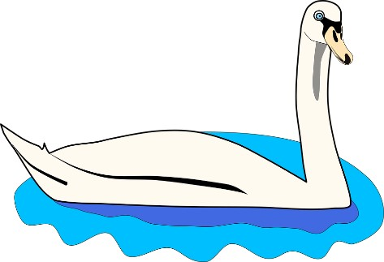*Highlight the adjectives in yellow*

Unit 2 Day 1

ANSWERS

The Swan

*Soft warm wings, gliding into land*

*Snow-white velvety feathers, stylishly on show*

*Long elegant neck, guiding this powerful airship*

*Night-black feet, to steady and propel*

*Delicate, piercing eyes, focused and calm*

*From flight to sailing yacht, the graceful swan transforms*

*Highlight the nouns in blue*

*Highlight the adjectives in yellow*

Unit 2 Day 1

**Bird cards**

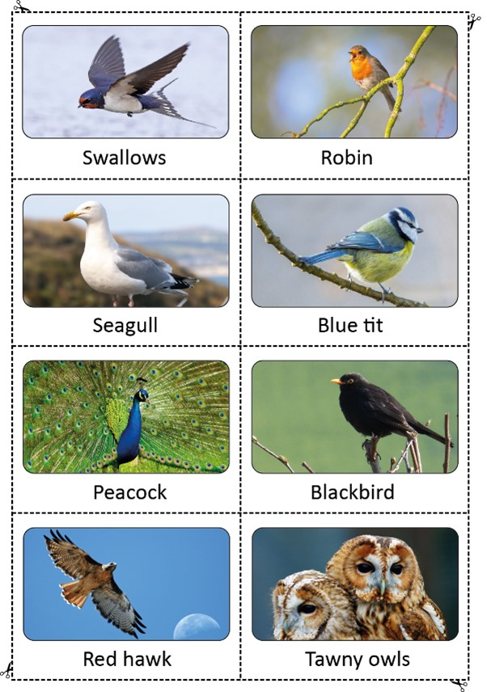*Cut out cards*

Unit 2 Day 1