Revision worksheet 1

1. Write two numbers to make this calculation correct.

+ + = 18

Now, write three numbers to make this calculation correct.

+ + = 18

1. Use any 2 numbers that make 10 or 20. Then add another number. Make 3 sentence.

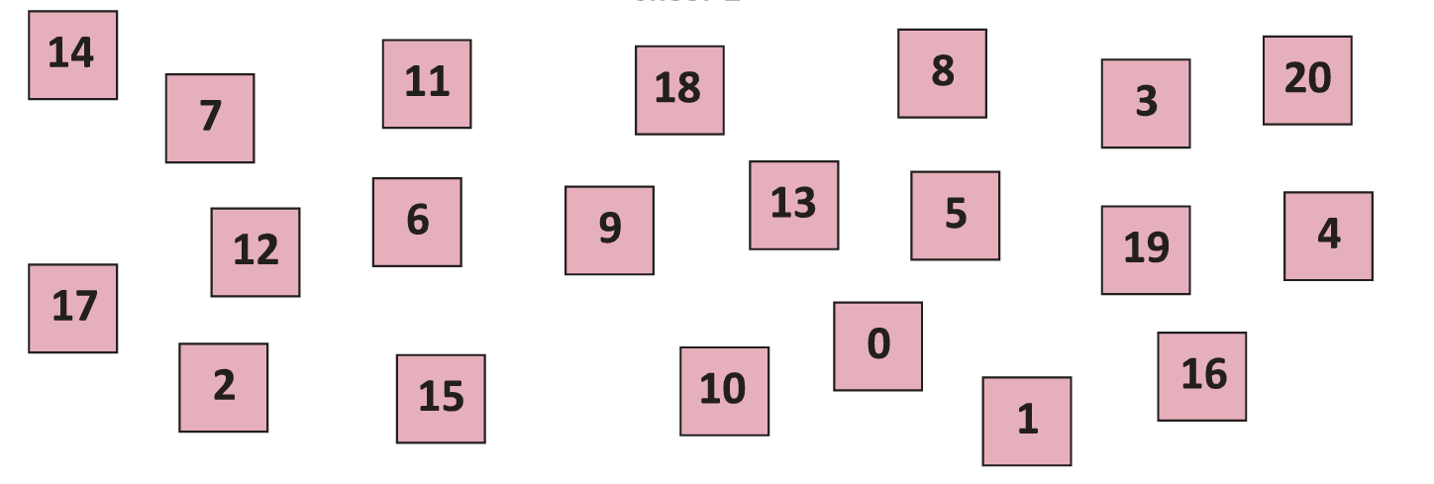

___________________________________________________

___________________________________________________

___________________________________________________

1. Find the missing number.

a) 25 + ______ = 25

b) 31 + 6 = ________

c) 14 + _____ = 20

1. Solve these questions.

a) 9 + 6 = ______, 39 + 6 = _________

b) 5 – 3 = ______, 15 - 3 = _________, 35 – 3 = ________

1. 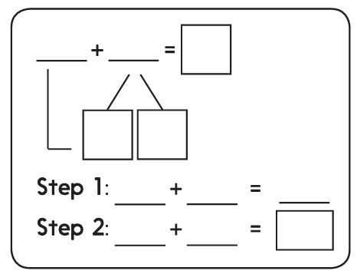Solve these questions using T10 strategy.

a) 48 + 5 =



b) 67 + 6 =

Teacher’s Signature:______________________ Parent’s Signature:________________