MS-WORD

Microsoft Word is a word processor developed by Microsoft. It was first

released in 1983 under the name Multi-Tool Word for Xenix systems. MS

Word is a popular word-processing program used primarily for creating

documents such as letters, brochures, learning activities, tests, quizzes and

students' homework assignments. There are many simple but useful features

available in Microsoft Word to make it easier for study and work. That's why

so many people would prefer to convert the read-only PDF to editable Word

and edit PDF in Word.

**Task no 1:**

1. Enter the data seen below in the spreadsheet.

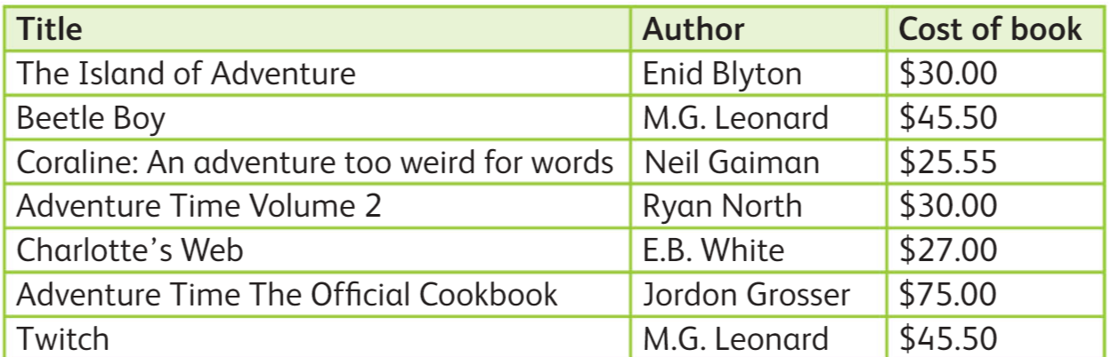

**Task no 2:**

Using the Find feature, search for all book titles with the word "Adventure".

1. How many book titles are there with the word "Adventure"?

___________________________________________________________________

1. State the cell address of the cells with the word "Adventure".

___________________________________________________________________

**Task no 3:**

Using the Find feature, narrow your search to find any book titles with the phrase, "Adventure Time".

1. How many book titles have the phrase, "Adventure Time"?

__________________________________________________________________

1. State the cell addresses of the cells with the book titles identified in question 3b.

___________________________________________________________________

|  |  |  |  |
| --- | --- | --- | --- |
| **Rubric for Phrase searching** | | | |
|  | 1 | 2 | 3 |
| Able to add data |  |  |  |
| Able to find the phrases |  |  |  |
| Able find the cell names |  |  |  |
| **Key**: 1. Needs more opportunity to develop this skill.  2. Beginning to demonstrate this skill.  3. Has achieved this skill. | | | |