Duration : 10 minutes Score : 10

1. Reflect the following shapes as described (3)

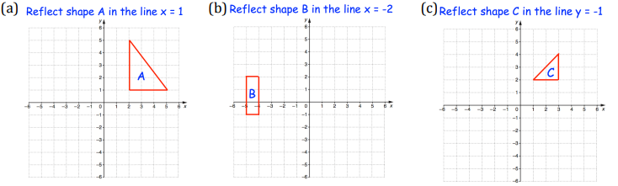

1. **Translate the triangle by the vector (2)**



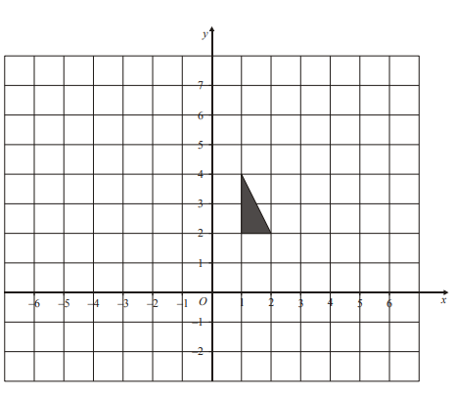

1. On the grid, enlarge the shaded triangle by a scale factor of 2, center C (3)

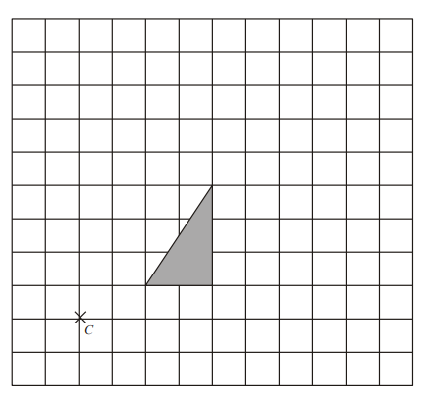

1. Rotate the following as described (2)

