1. Describe fully the single transformation that maps trapezium P on trapezium Q.

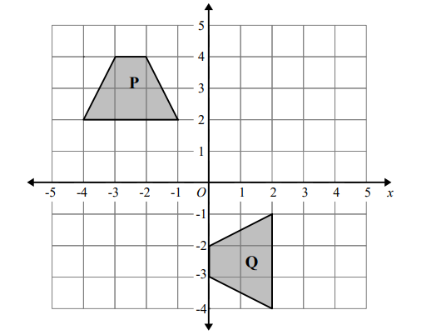

1. Reflect shape A in the line with equation y = x

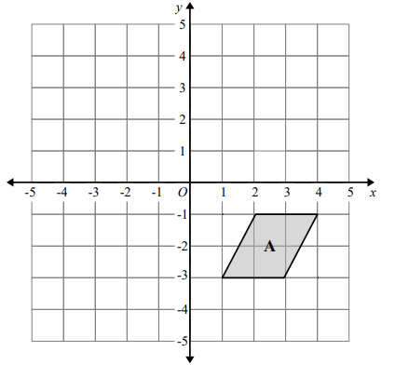

1. Describe fully the single transformation that maps shape A onto shape B.

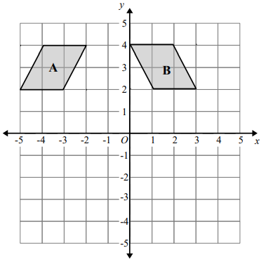

1. Enlarge the shaded triangle by scale factor 3, center O

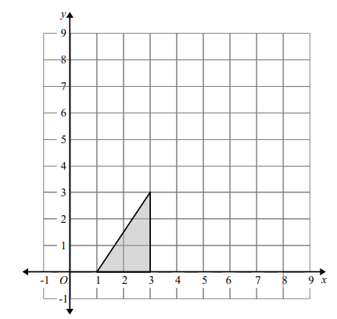

1. Shape A is transformed to shape B by a reflection in the x axis followed by a translation



Find the value of p and the value of q

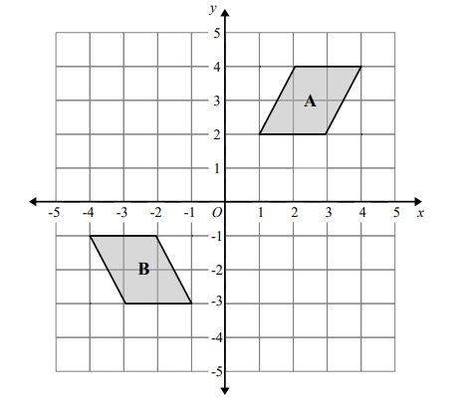

1. **Do the following transformations in the following grid**

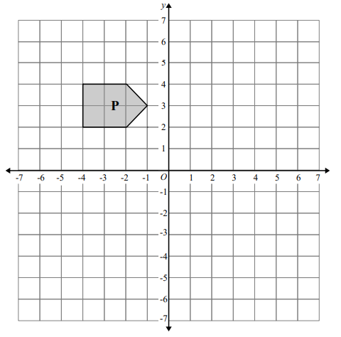

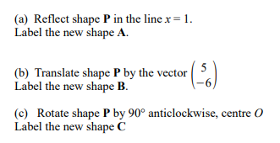

1. Translate the shape by the vector



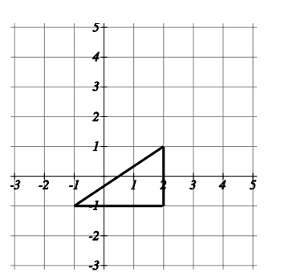

1. Enlarge the shaded triangle by a scale factor 2, centre 0.

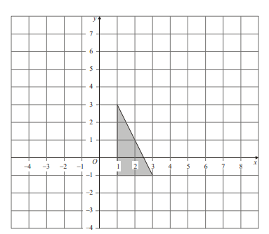

1. Describe fully the single transformation which takes shape A onto shape B.

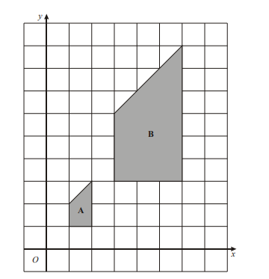

1. Reflect each shape in the mirror line given

