1. **Jamila wants to know if a colourless liquid contains a dissolved solid. She heats the liquid until it boils. Jamila measures the boiling point of the liquid.**
2. What is the meaning of the words boiling point?

____________________________________________________________________________________________________________

____________________________________________________________________________________________________________

1. Angelique tells Jamila to keep heating the liquid until all the liquid has boiled away. What will Jamila see if the liquid contains a dissolved solid?

____________________________________________________________________________________________________________

____________________________________________________________________________________________________________

**II. Mia finds this information about some substances at room temperature.**

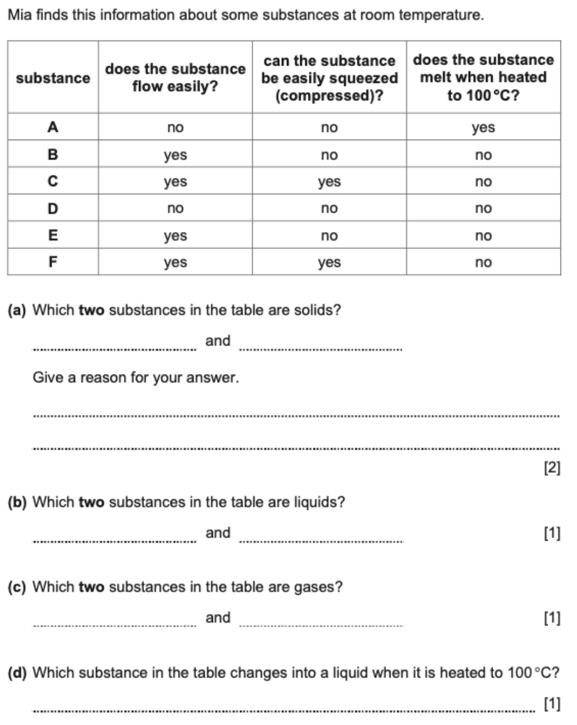

1. Which two substances in the table are solids? Give a reason for your answer.

____________________________________________________________________________________________________________

____________________________________________________________________________________________________________

1. Which two substances in the table are liquids?

____________________________________________________________________________________________________________

1. Which two substances in the table are gases?

____________________________________________________________________________________________________________

1. Which substance in the table changes into a liquid when it is heated to 100 °C?

____________________________________________________________________________________________________________

**III. Mercury vapour is very poisonous. Mercury is a silver-coloured liquid at room temperature.**

**Liquid mercury has to be cooled to make solid mercury.**

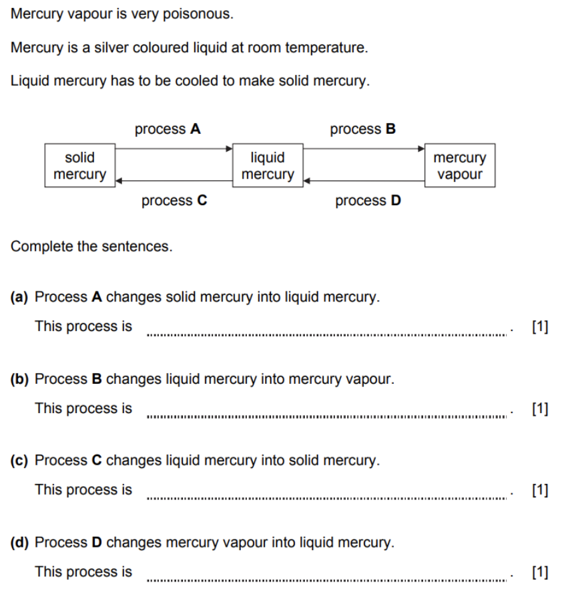

Complete the sentences.

1. Process A changes solid mercury into liquid mercury.

This process is _______________________________

1. Process B changes liquid mercury into mercury vapour.

This process is _______________________________

1. Process C changes liquid mercury into solid mercury.

This process is _______________________________

1. Process D changes mercury vapour into liquid mercury.

This process is _______________________________

**IV. Match the following processes to the correct change of state.**

Draw a line between the **process** and the correct **change of state**.

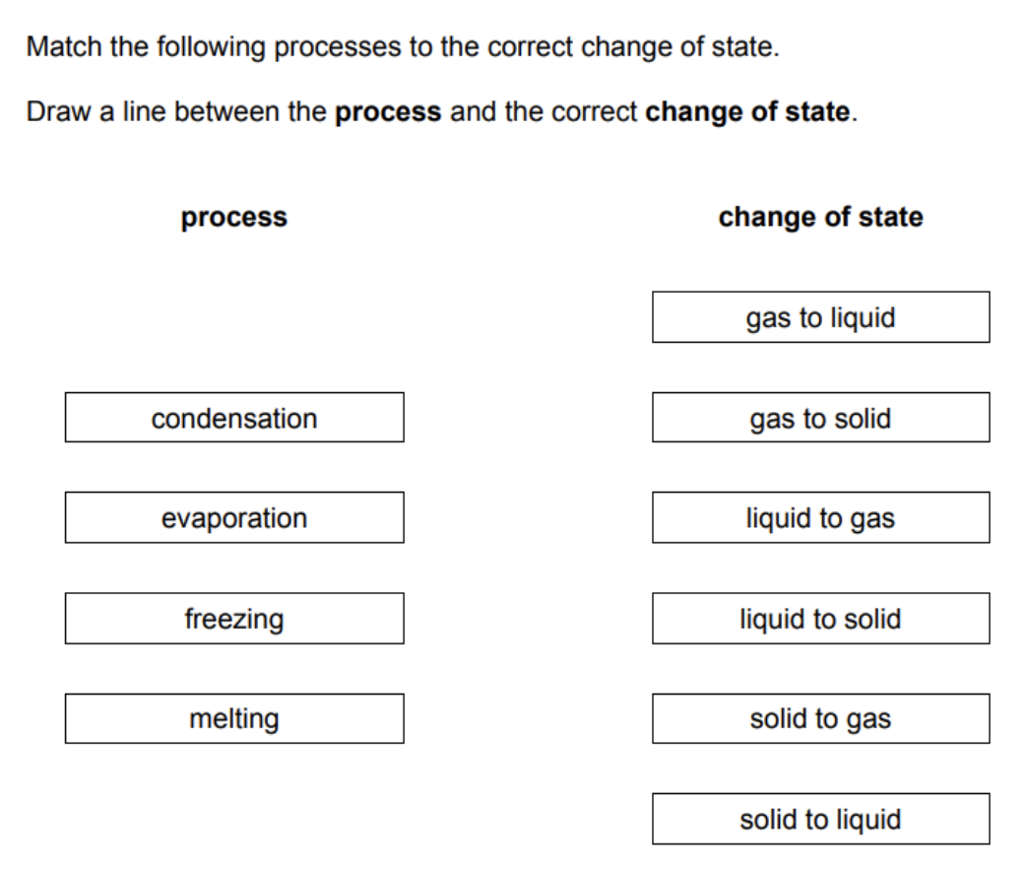

**V. When a substance is mixed with water it may dissolve. Complete the sentences about adding substances to**

**water.**

Choose from the words.

**insoluble soluble solution residue solute solvent**

* A liquid that dissolves a solid is called a _______________________________
* ﻿﻿﻿﻿A substance that does not dissolve in water is ______________________________
* A substance that dissolves in water is __________________________________
* ﻿﻿﻿﻿A substance is dissolved in water. This substance is called the ____________________________
* ﻿﻿﻿﻿The mixture of a substance dissolved in water is called a ________________________________

**VI. Here is a list of sentences. Decide if each sentence is true or false.**

**Tick (v) the correct box.**

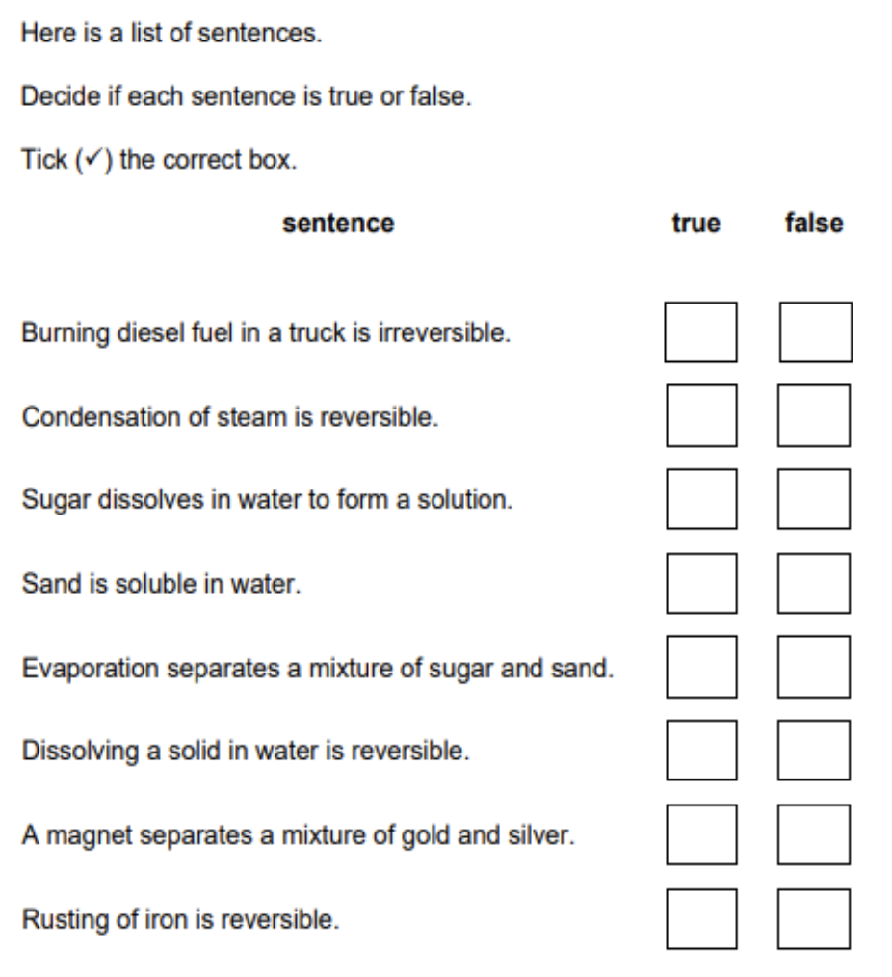

**VII.**



