1. Open new project in scratchjr
2. add any background
3. add the person character
4. add a child character
5. Complete the algorithm for the Child as following:

* Start on Bump
* move up (4)
* jump (2)
* move left (1)
* turn right (12)
* stop program

to test it place both character close enough

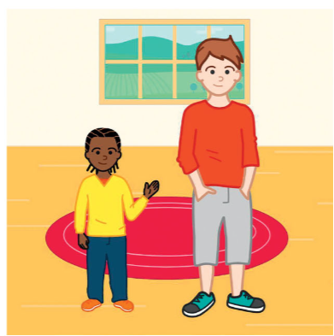  
  
Extension task:

