QUIZ-6
Chapter 2(Marking Scheme)

Sl.No | Answers | Marks
1.a | 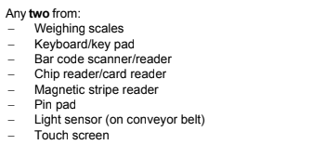 | 2
1.b | 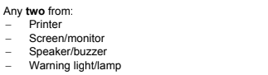 | 2
2 | 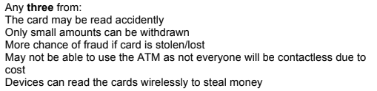 | 3
3 | 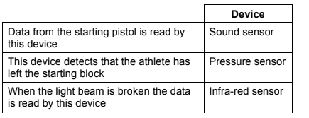 | 3

