1. **Write T if the statement is True and write an F if the statement is False.**

# 

1. Code is a language that tells the computer what to do.

1. Computers are used in the library too keep a record of books.

1. Sorting data means grouping data that is common.

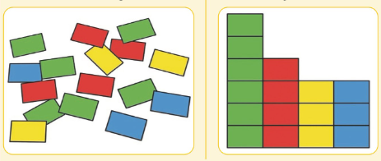

1. We can count our walking steps through Laptop.

1. **Order the following data.**

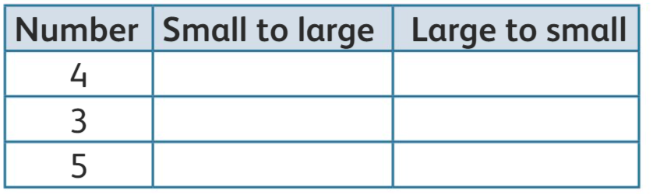

1. **Complete the steps of the algorithm in the correct order.**

1. **Complete the following.**

