**I Fill in the blanks.**

Online link device internet

Works Hop Correctly Fixing

a) To make your character jump, you should use the ___________ block.

b) Testing is when you run your program to see if it _____________.

c) Debugging means finding and ___________ mistakes in your program.

d) It’s important to test your program frequently to ensure it works __________.

e) Google Forms is an _____________ form.

f) To fill out Google Forms you need a _______________,for example a computer.

g) You will also need _______________access and а ________________to the Google Forms template.

**II. Draw a line to match the type of form with the data to be**

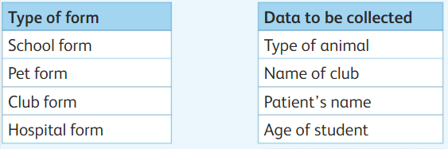 

**III Write the steps in the right order to finish drawing a square.**

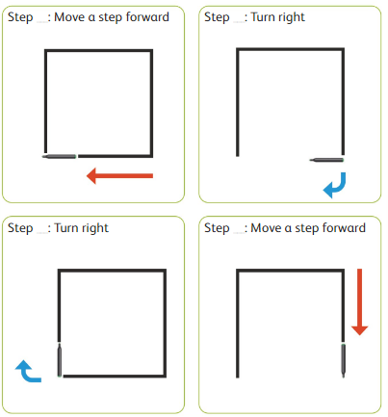

**IV. Match the following.**

|  |
| --- |
|  |
|  |
|  |
|  |
|  |

|  |
| --- |
| 1. Move forward 1 step |
| 1. Turn right |
| 1. Turn left |
| 1. Move backward 1 step |
| 1. Stop program |

**V. Write the missing letter.**

1. D__b__g
2. T__ s__
3. D__t__
4. F__r__s