QUIZ-5
DESIGN STAGE (Marking Scheme)

Sl.No | Answers | Marks
1 | 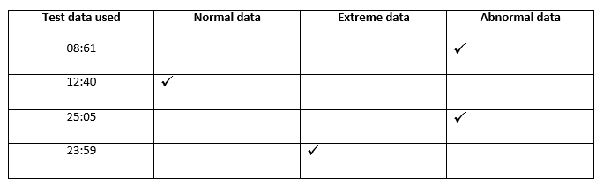 | 4
2 | 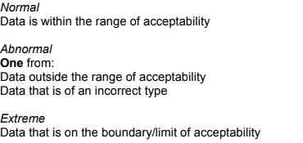 | 3
3.a | 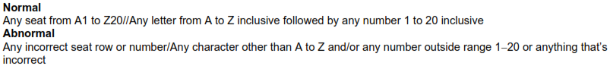 | 2
3.b | 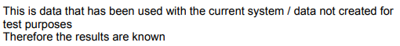 | 1

