**QUIZ-4**

**DEVELOPMENT & TESTING (GRADED)**

1. A bus company uses a spreadsheet to produce its timetable. Times are entered using the 24-hour clock (hh:mm). The four pieces of data in column one have been used to test the system. Put a single tick in each row to show the type of test data being used.

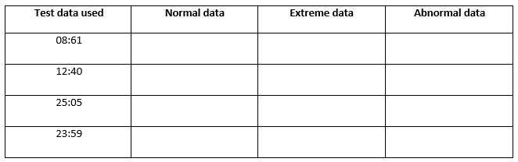

[4]

1. When the new computer system has been produced, it will need to be tested. There are three types of test data that can be used to test a system, normal, abnormal and extreme.

Explain what is meant by normal, abnormal and extreme test data.

Normal...................................................................................................................................................

...............................................................................................................................................................

Abnormal...............................................................................................................................................

...............................................................................................................................................................

Extreme.................................................................................................................................................

...........................................................................................................................................................[3]

1. The manager of a cinema has purchased a new booking system. There are 26 rows in the cinema

with 20 seats on a row. Each seat is identified by a unique ID. The seat ID consists of the row letter

followed by the position of the seat on the row. An example of the seat on row F position 12 would

be F12.

He is setting up a test plan to test the system.

1. Write down **one** example of each of the following types of test data. The answers must be

different in each case.

Normal ..................................................................................................................................................

Abnormal ...........................................................................................................................................[2]

1. Describe what is meant by live data.

………………………………………………………………………………………………………………………………………………………………………………………………………………………………………[1]