Convert  200 cm to  - Metre  - Millimeter | Convert  - 27500 ml to Litre  - 2.1 L to ml
Convert the following lengths into metres  - 0.8 km  - 0.006 km | Convert the following into litres  - 1035,ml  - 88 ml
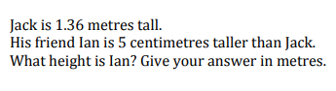 | 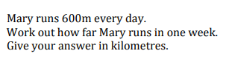
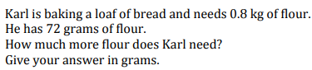   | A bucket weighs 800g When half filled with water, the bucket weighs 4.5kg. Work out the weight when the bucket is filled with water
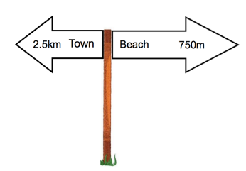  Work out the distance between the town and the beach. State your units. | If a tank can hold 8000 milliliters of oil, how many liters is that?
John wants to purchase a 2.5-liter bottle of soda. If each cup can hold 250 milliliters, how many cups will he need to fill from the bottle? | Sarah ran 6 kilometers in the morning and 3,500 meters in the evening. How many total meters did she run?

