Exit ticket

1. Shown below is a rectangle.

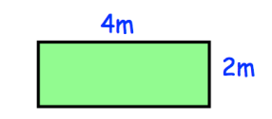

1. Find the area of the rectangle in m²
2. Find the area of the rectangle in cm²

2. Shown below is a cube

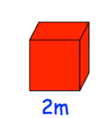

1. Find the volume of the cube in m³

b) Find the volume of the volume in cm³