

**Week 10 Day 5 Task 1: Woking at ARE**

**Pairs – independent or with TA**

* Roll a 1–10 dice and take that number of 10p coins.
* Count the total and write a sentence, e.g. *7 lots of 10p = 70p*.
* Repeat the same activity with 2p coins.

|  |  |
| --- | --- |
| Learning Outcomes/Rubrics: | |
| I can count in 10s and 2s. |  |
| I can understand multiplication as repeated addition. |  |

**Day 5 task 2:**

Solve sheet 2.



**Week 10 Day 5 Task 1: Woking towards ARE**

**Pairs – Independent or with T/TA**

* Roll a 1–6 dice and take that number of 10p coins.
* Count the total and write a sentence, e.g. *4 lots of 2p = 8p*.
* Repeat the same activity with 2p coins.
* You can draw the coins and write the total by the side, e.g.

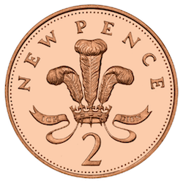    4 lots of 2p = 8p

|  |  |
| --- | --- |
| Learning Outcomes/Rubrics: | |
| I can count in 10s and 2s. |  |
| I can understand multiplication as repeated addition. |  |

**Day 5 task 2:**

Solve sheet 1.



**Week 10 Day 5 Task 1:**

* Roll a 1–10 dice and take that number of 10p coins.
* Count the total and write a multiplication sentence like 7 × 10p = 70p
* Repeat the same activity with 2p coins.

|  |  |
| --- | --- |
| Learning Outcomes/Rubrics: | |
| I can count in 10s and 2s and write number sentences using the multiplication sign |  |
| I can reason about multiples of 2 and 10. |  |

**Day 5 task 2:**

Solve sheet 2.