**Haiku about birds**

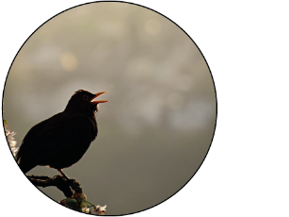

Birds singing

in the dark

—Rainy dawn.

*Jack Kerouac*

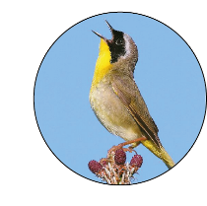

Birds chirping a lot

People singing all the time

Birds are going south!

*Nicholas*

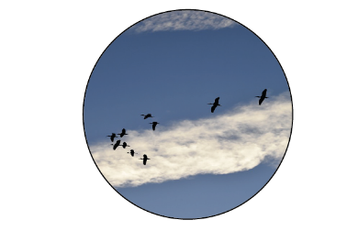

Egrets move through the marsh...

morning clouds

*Edward Weiss*

Unit 2 Day 3

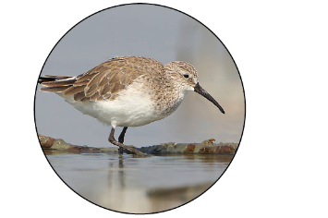 Winter shoreline –

sandpipers dart

into the water

*Edward Weiss*

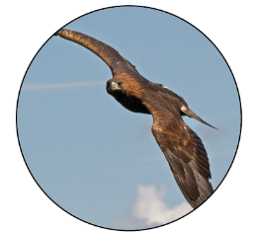

Sunrise –

Golden eagles soar

On the thermals

*Edward Weiss*

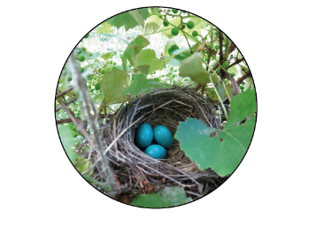

Quiet forest –

A piece of straw

Falls off the robins nest

*Edward Weiss*

*Haiku is a short form of Japanese poetry, often about nature. Traditionally they are 3 lines with 5, 7, 5 syllables.*

*But when translated, they may not follow this pattern.*

*They often contain 2 images and a season or weather word.*

Unit 2 Day 3

**Bird Images**

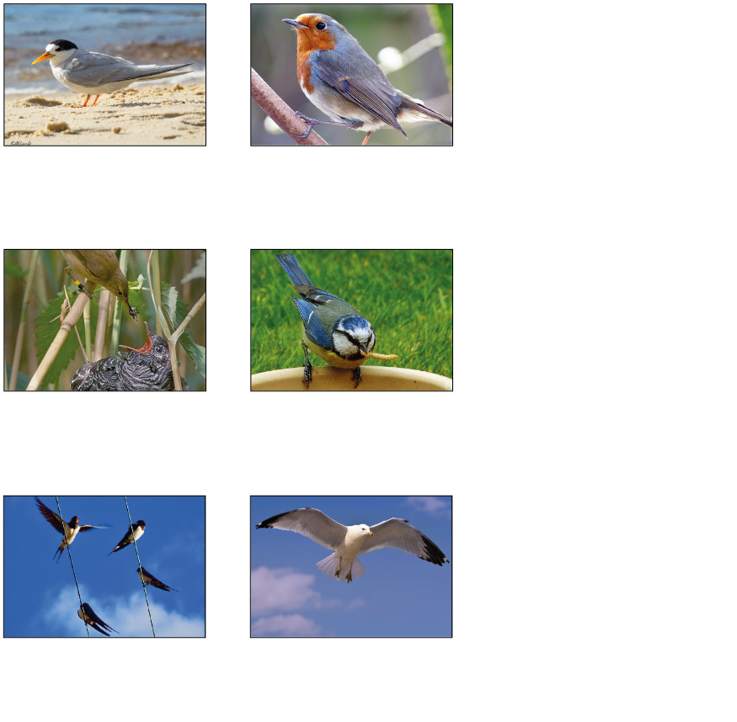

Unit 2 Day 3 and 4

Cuckoo & Reed

warbler

Seagull

Swallows

Blue tit

Fairy tern

Robin

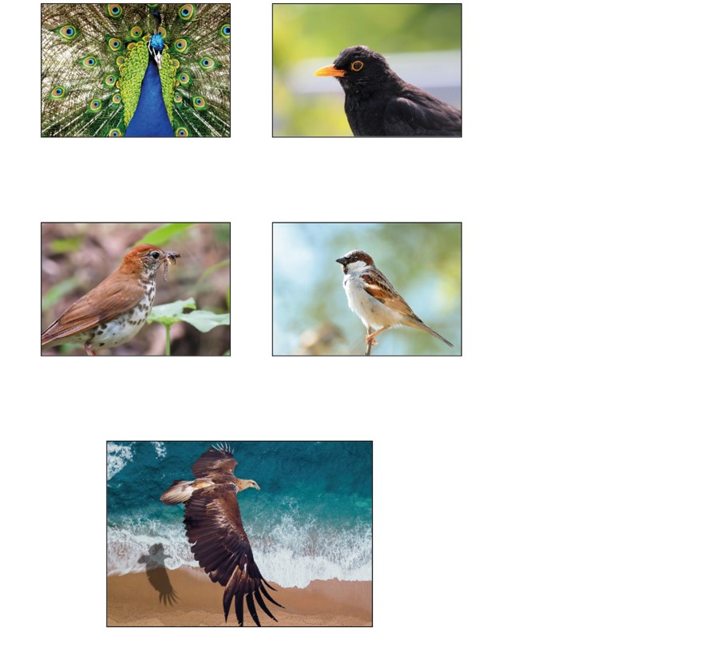

Unit 2 Day 3

Golden eagle

Sparrow

Thrush

Peacock

Blackbird

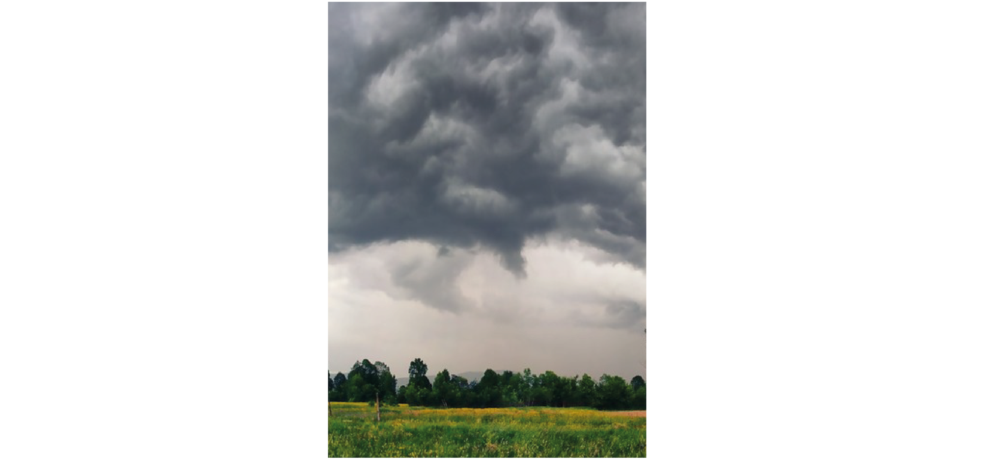Weather Words

|  |  |
| --- | --- |
| **wintery weather** | **snow and sleet** |
| **blustery wind** | **driving rain** |
| **summer sunshine** | **fluffy clouds** |
| **gentle drizzle** |  |

Unit 2 Day 3