|  |  |  |
| --- | --- | --- |
| Term: II  Session: 2023 – 2024 |  | Name: Date: |

Highlight noun phrases in green and underline prepositions.

**Haiku**

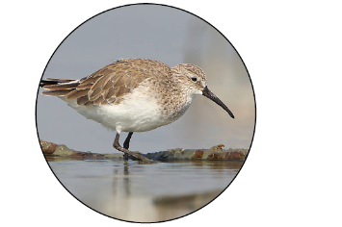 Winter shoreline –

sandpipers dart

into the water

*Edward Weiss*



Sunrise –

Golden eagles soar

On the thermals

*Edward Weiss*

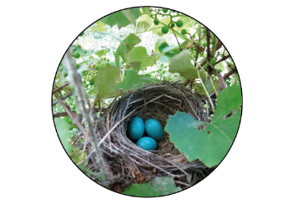

Quiet forest –

A piece of straw

Falls off the robins nest

*Edward Weiss*

*Haiku is a short form of Japanese poetry, often about nature. Traditionally they are 3 lines with 5, 7, 5 syllables.*

*But when translated, they may not follow this pattern.*

*They often contain 2 images and a season or weather word.*

Lit – Yr. II Homework -Worksheet Ms. Spougmay

|  |  |  |
| --- | --- | --- |
| Term: II  Session: 2023 – 2024 |  | Name: Date: |

Challenge: Following the haiku pattern (examples from page 1), choose a bird and compose short phrases or sentences using noun phrases and prepositions about it.

___________________________________________________________________________________________________

Lit – Yr. II Homework -Worksheet Ms. Spougmay