**TASK A:**

**You are required to make a Quiz game in scratch 3.0 by following the below algorithm.**

In this game the user should be asked two mathematics Questions. They should:

* Gain 1 point for each correct answer
* Lose 1 point for each wrong answer
* Start the score at zero.

|  |  |
| --- | --- |
| **STEP** | **ALGORITHM** |
| **1** | **Start program when the green flag is clicked** |
| **2** | **Create variable Score** |
| **3** | **Create variable Answer** |
| **4** | **Set Score to 0** |
| **5** | **Ask “ What is 10 + 2 ?” and wait** |
| **6** | |  |  | | --- | --- | | **6.1** | **If Answer = “12”, then:** | | **6.2** | **Set variable Score = Score + 5** | | **6.3** | **Say “ Correct for two seconds”** | | **6.4** | **Else:** | | **6.4.1** | **Set variable Score = Score – 5** | | **6.4.2** | **Say “ Wrong for two seconds”** | |
| **8** | **Ask “ What is 10 - 2 ?” and wait** |
| **9** | |  |  | | --- | --- | | **9.1** | **If ________ = “8”, then:** | | **9.2** | **If Set variable Score = Score + 5** | | **9.3** | **Else:** | | **9.4** | **Set variable Score = Score – 5** | | **9.5** | **Say “ Wrong for two seconds”** | |

**TASK B:**

Create a new program for the **penguin** sprite to do the following:

* When the space key is pressed , the penguin should ask two questions and the user should be able to type an answer for each question
* The user start with 10 points
* If the answer is correct , the user gains 5 points
* If the answer is wrong, the user loses 5 points.
* 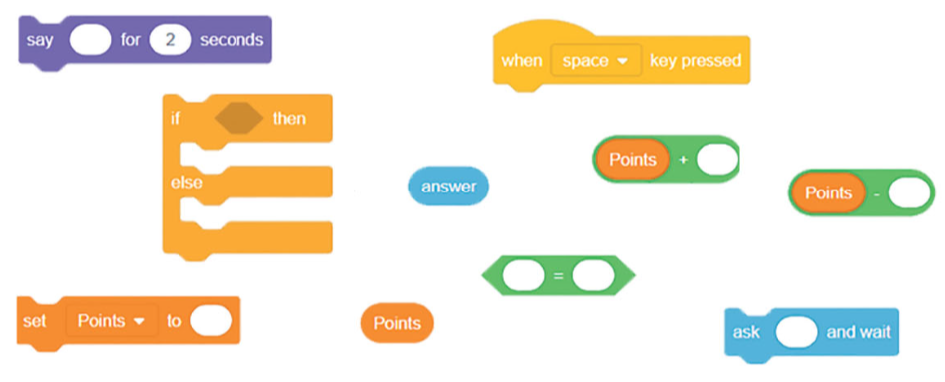Use all the coding block shown below in your program.

**TASK C:**

**In this task you are required to make dice game in MakeCode using Microbit by**

**Applying the following steps in your program:**

1. Open Google , Type MakeCode and click on the first link.
2. Create a new project by your name.
3. Remove the existing blocks from the interface.
4. Click on Input and select on button **A** is pressed.
5. Click on variable and create a variable by **dice** name.
6. Click on **set dice to** and join it with **pick random** from maths block.
7. Put random number **first value 1 and second value 6**.
8. Click on logic block and select If.
9. If dice equal to 1 then:

* Show number 1 on LED
* Show string “One”.

1. If dice equal to 2 then:

* Show number 2
* Show string “Two”.

1. Similarly do till dice value equal to 6.
2. Run and test your code.