Week 30 SCI Plenary Day 2

1. Why is it important to give your pet clean water to drink? How can you help make sure your pet always has fresh water?
2. My pet doesn’t need water.
3. I give water in a clean bowl and keep the bowl clean after every use.
4. I can give water in any available utensil and do not keep it clean.
5. How can you create a safe and cozy space for your pet to relax?
   1. Leave the pets inside the cages
   2. Provide a healthy and safe habitat at home.
   3. Give food that they don't eat at all.
6. Are you aware of any group of communities in Qatar that takes care of animal welfare?
   1. Qatar Airways
   2. Education for all Community
   3. Qatar Foundation
   4. Qatar Animal Welfare Society
7. How do you take care of your pet's fur or feathers?
   1. I brush my pet's fur to keep it soft.
   2. I do not have to take care of my pet’s fur.
   3. I will cut the fur.
8. Why is it important to take your pet to the vet sometimes?
   1. I take my pet to the vet to stay happy and healthy.
   2. My pet does not need a vet.
   3. I take my pet to my friend’s house to get him checked.

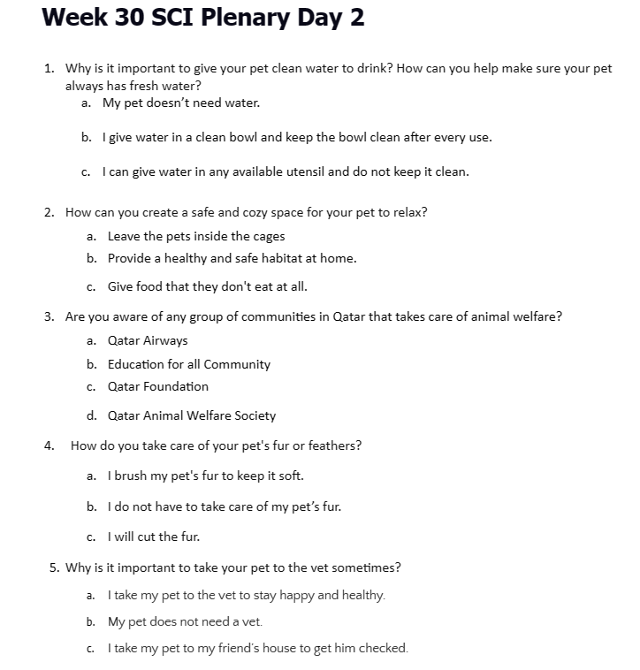

1. Qatar Airways
2. Education for all Community C Qatar Foundation
3. D Qatar Animal Welfare Society
4. How do you make your pet happy and healthy?
   1. Leave the pets inside the cages
   2. Provide a healthy and safe habitat at home. C Give food that they don't eat at all.
5. Which group of community in Qatar takes care of animal welfare?
6. Qatar Airways
7. Education for all Community C Qatar Foundation

D Qatar Animal Welfare Society