**Marketing Mix: product**

**Starter activity:**

|  |  |
| --- | --- |
| **Key terms** | **Definition** |
| Marketing mix |  |
| product |  |
| brand |  |
| Unique selling point/proposition |  |

**What are the four P’s of the marketing mix?**

**……………………………………………………………………………………………………………………………………………………………….**

**……………………………………………………………………………………………………………………………………………………………….**

**……………………………………………………………………………………………………………………………………………………………….**

**……………………………………………………………………………………………………………………………………………………………….**

**Describe what makes a successful product?**

**……………………………………………………………………………………………………………………………………………………………….**

**……………………………………………………………………………………………………………………………………………………………….**

**……………………………………………………………………………………………………………………………………………………………….**

**……………………………………………………………………………………………………………………………………………………………….**

**Support notes:**

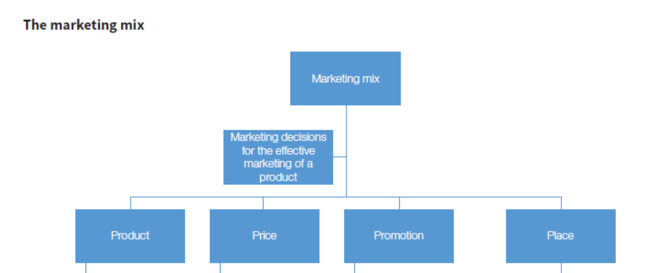

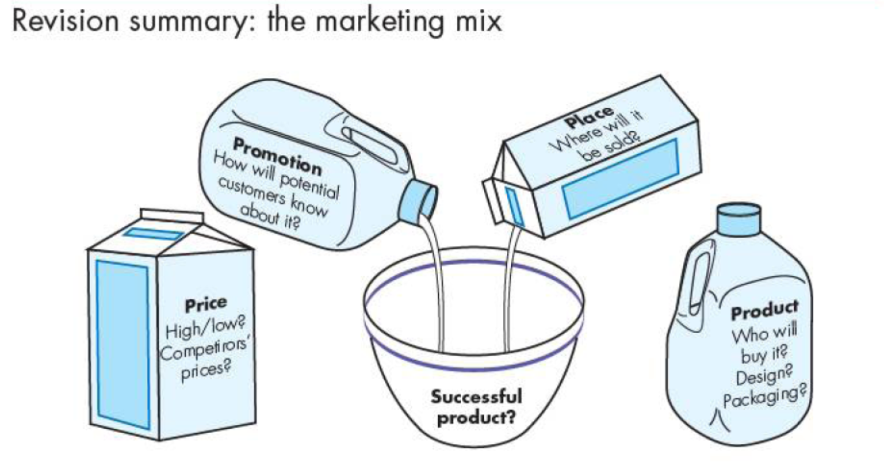

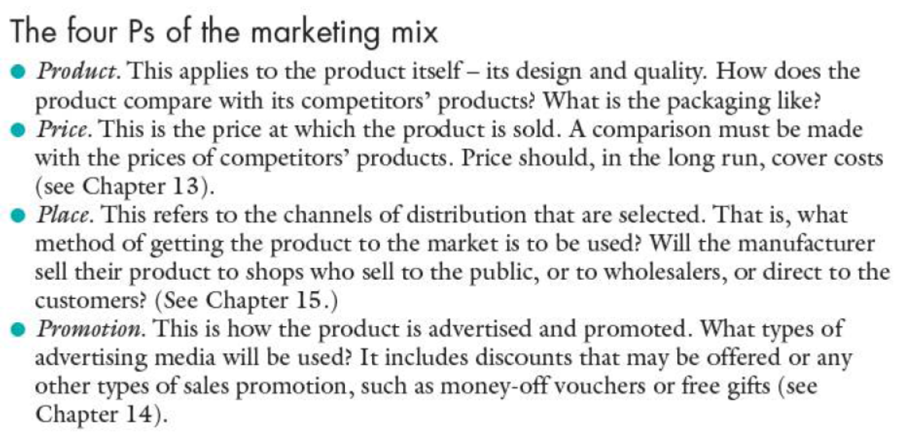

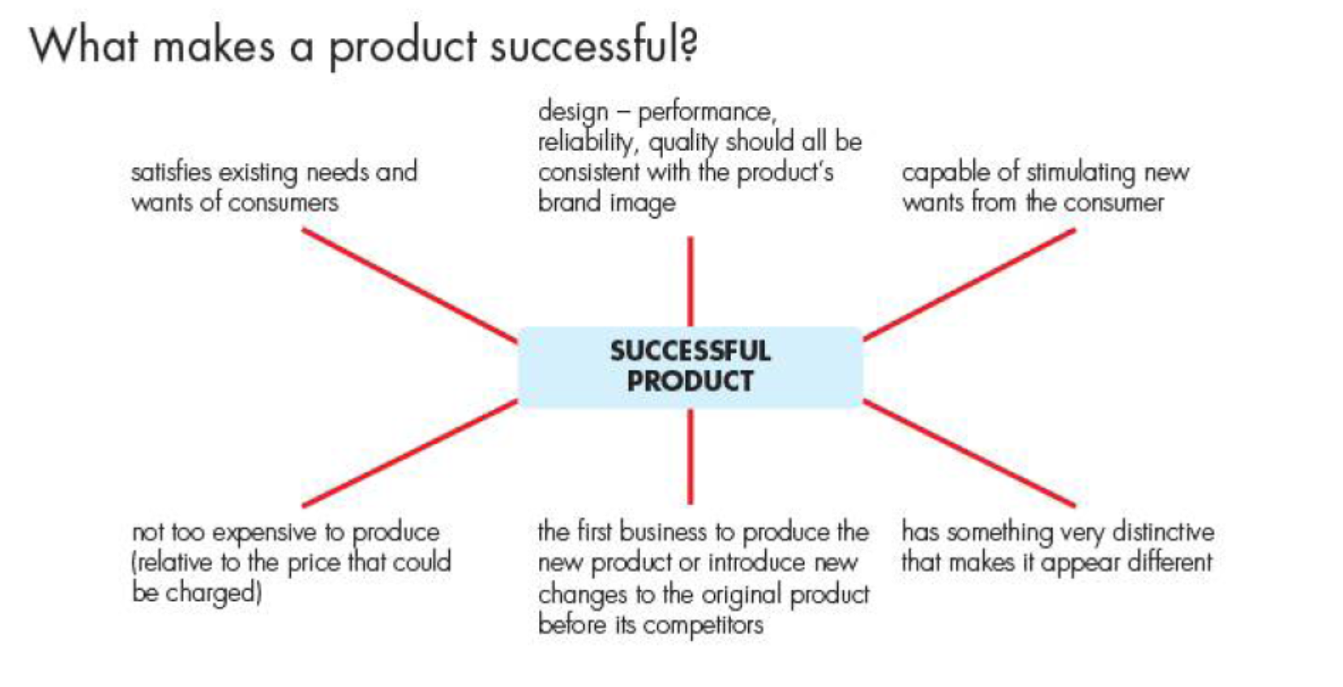

**Development activity:**

After watching the video, construct a flowchart outlining the main stages of product development.

Extension task (optional): Make a written summary to explain what happens in each stage and why it is important.

**……………………………………………………………………………………………………………………………………………………………….**

**……………………………………………………………………………………………………………………………………………………………….**

**……………………………………………………………………………………………………………………………………………………………….**

**……………………………………………………………………………………………………………………………………………………………….**

**……………………………………………………………………………………………………………………………………………………………….**

**……………………………………………………………………………………………………………………………………………………………….**

**……………………………………………………………………………………………………………………………………………………………….**

**……………………………………………………………………………………………………………………………………………………………….**

**……………………………………………………………………………………………………………………………………………………………….**

**……………………………………………………………………………………………………………………………………………………………….**

**……………………………………………………………………………………………………………………………………………………………….**

**Practice Activity:**

List the costs and benefits of new product development.

|  |  |
| --- | --- |
| **Costs** | **Benefits** |
|  |  |
|  |  |
|  |  |
|  |  |
|  |  |

OR

Extension task: Make a brief written report outlining the possible costs and benefits of developing a different new product.

**……………………………………………………………………………………………………………………………………………………………….**

**……………………………………………………………………………………………………………………………………………………………….**

**……………………………………………………………………………………………………………………………………………………………….**

**……………………………………………………………………………………………………………………………………………………………….**

**……………………………………………………………………………………………………………………………………………………………….**

**……………………………………………………………………………………………………………………………………………………………….**

**……………………………………………………………………………………………………………………………………………………………….**

**……………………………………………………………………………………………………………………………………………………………….**

**……………………………………………………………………………………………………………………………………………………………….**

**……………………………………………………………………………………………………………………………………………………………….**

**……………………………………………………………………………………………………………………………………………………………….**

**……………………………………………………………………………………………………………………………………………………………….**

**……………………………………………………………………………………………………………………………………………………………….**

**……………………………………………………………………………………………………………………………………………………………….**

**……………………………………………………………………………………………………………………………………………………………….**

**……………………………………………………………………………………………………………………………………………………………….**

**Support notes:**

Most businesses go through the following process of product development:

