**FLY YOUR FRACTIONS**

**Instructions: 15 marks**

1. Use 5 different colours to design the kite.
2. After coloring the kite, determine the fractional amount of each color used on the kite and record these fractions on the cloud.
3. Cut out the kite and glue the kite to the cloud and a streamer tail made of colour papers.

**Calculations: 5 marks**

1. Order the fractions formed, starting from the smallest.
2. Choose any other pair of fractions and add them, write the answer in the simplified form if applicable.

**Investigation: 5 marks**

Look at the first fraction picture.

Work out what fraction each colour is of the whole picture. You can use the fraction wall

for this question.

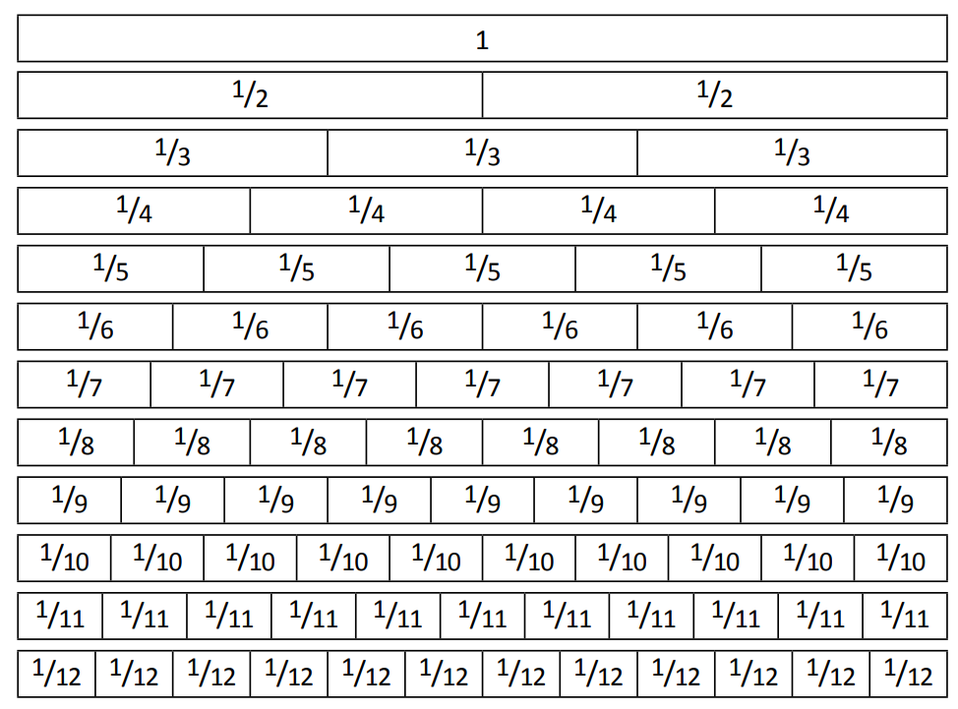

Calculations:

1. Order the fractions formed, starting from the smallest.
2. Choose any other pair of fractions and add them, write the answer in the simplified form if applicable.

Investigation: Work out what fraction each colour is of the whole picture.

Orange: ______ Grey: ______

Blue: ________ Pink: ______

Green: _______

