**PRACTICAL WORKSHEET**

**BASIC FORMATTING TAGS**

1. Open notepad
2. Create a html page with name “PRACTISE.html”
3. Edit the html page as follows

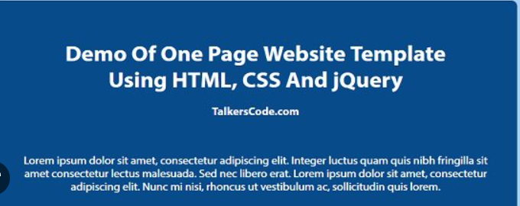

1. Save the notepad
2. Display the html page in your browser.