1. **Circle the letter of the correct answer.**

1. Sarah had a big glass of water. After some time, she needed to go to the bathroom. Why did this happen?

a. To wash her hands

b. To check her appearance

c. To get rid of waste products in her body

d. To find a quiet place

2. Which process allows plants and animals to become larger and develop over time?

a. Sleeping

b. Reading books

c. Growth

d. Eating sweets

3. A butterfly lays eggs on a leaf. What does this action lead to in terms of the life process?

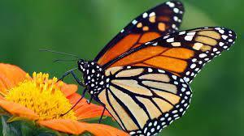

a. Growth

b. Sensitivity

c. Reproduction

d. Excretion

4. Tim planted a seed in a pot. After a few weeks, he observed a small plant. What life process is Tim witnessing?

a. Sensitivity

b. Reproduction

c. Growth

d. Excretion

5. Plants react to their environment as they can respond to light and temperature. What do we call this life process?

a. Respiration

b. Sensitivity

c. Excretion

d. Reproduction

6. Imagine you have a beautiful sunflower in your garden. During the day, it always turn its faces towards the Sun. What life process is this an example of?

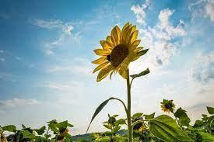

a. respiration

b. growth

c. excretion

d. movement

7. You have learned that “Excretion” means “Get rid of waste from the body”. Can you explain how do plants excrete?

_________________________________________________________________________________________________________________________________________________________________________________________________________________________________

8. Sort the things shown in the picture into the three groups shown in the table below.

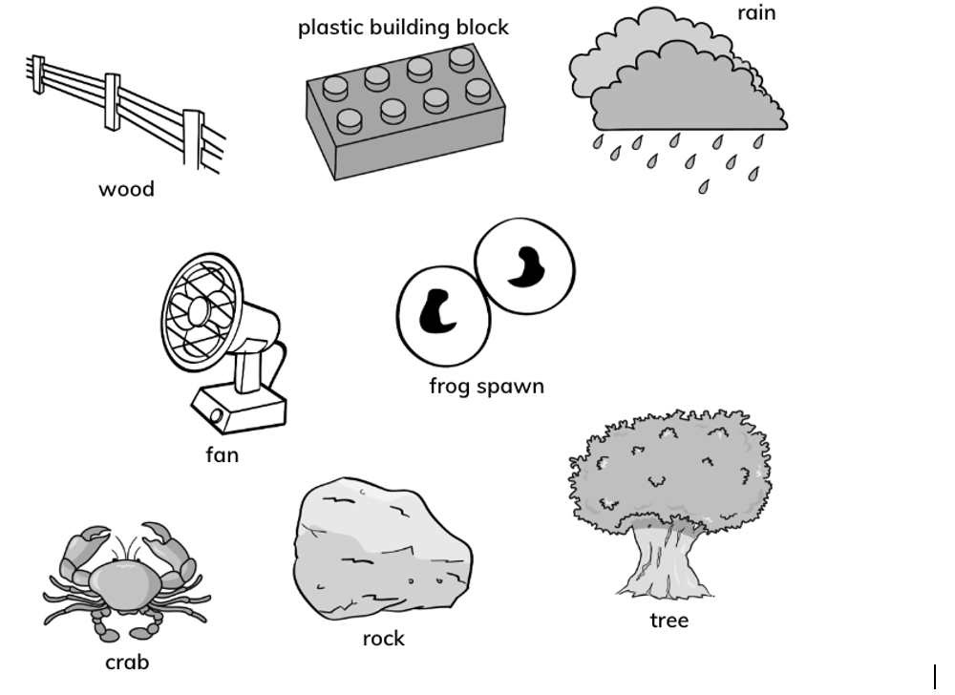

|  |  |  |
| --- | --- | --- |
| **Living things** | **Things that were once alive** | **Things that have never been alive** |
|  |  |  |

**9. The mango tree produces fruit.**

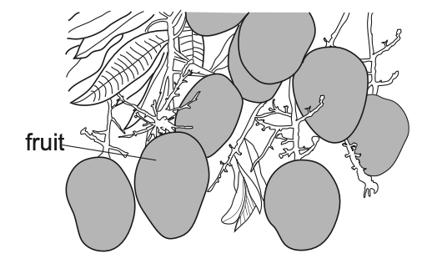

The fruit contains seeds. The seeds are used to grow new mango trees.

1. What is this life process called?

_________________________________________________________________

1. The mango tree produces lots of fruit.

Why does it produce lots of fruit?

Circle the correct answer.

to collect light

to collect water

to help the tree grow

to look pretty

to make many seeds

10. Plants are living things. How do plants move?

_________________________________________________________________________________________________________________________________________________________________________________________________________________________________