1. **Loot at the items in the table below. Write magnetic or non-magnetic in front of each object.**

**Magnetic/ Non-Magnetic**

1. **Fill in the blanks by using the words given in the table above.**

|  |  |  |  |  |
| --- | --- | --- | --- | --- |
| iron | Unlike | nickel | like | repel |
| End | steel | North-South | attract | cobalt |

1. Not all metals are magnetic. Some metals that can attract to magnet are ______________, ______________, ______________, ________________.
2. When a magnet is hung freely and come to rest (stop moving) it will point to the _____________________________.
3. When two ______________ poles are brought together, they push each other away. They will ________________________ each other.
4. When two _________________ poles are brought together, they pull each other. They will _______________________ each other.
5. The strongest part of the magnet is at the _________________ of both poles.
6. **Observe the following pictures.**

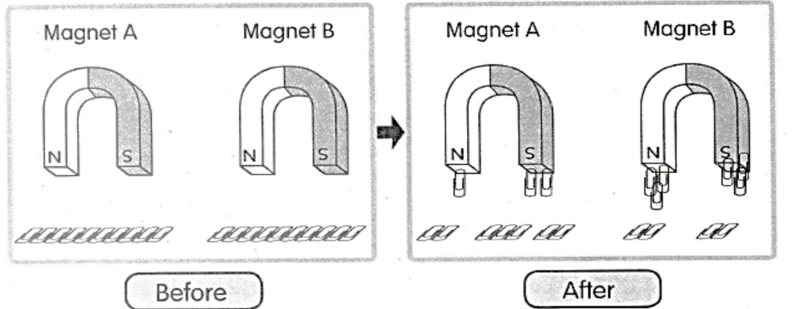

Answer the following questions.

1. How many paper clips are attracted to the following magnets?

Magnet A: ______________

Magnet B: ______________

1. Which magnet is stronger? Why?

__________________________________________________________________________________________________________________________________________________________________________________________________________________________________________

1. The magnet that attracts more paper clips is ________________ (stronger/weaker).
2. **Colour and label the following magnet. Use “Red” and “Blue” colours.**

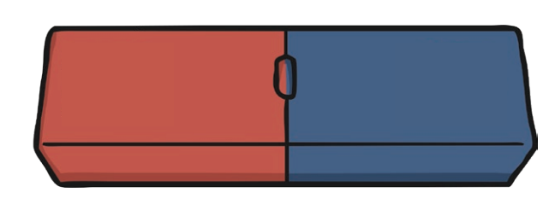

1. What will happen if you put the ends of the same colour together?

___________________________________________________________________

1. What will happen if you put a red and a blue end together?

_____________________________________________________________________