Revision – Chapter 4 – Software-Marking Scheme
1. | 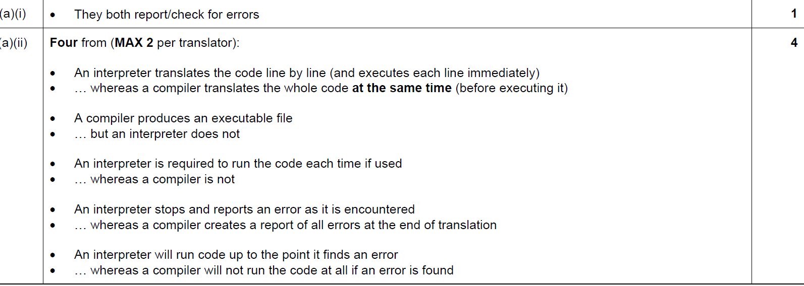
2. | 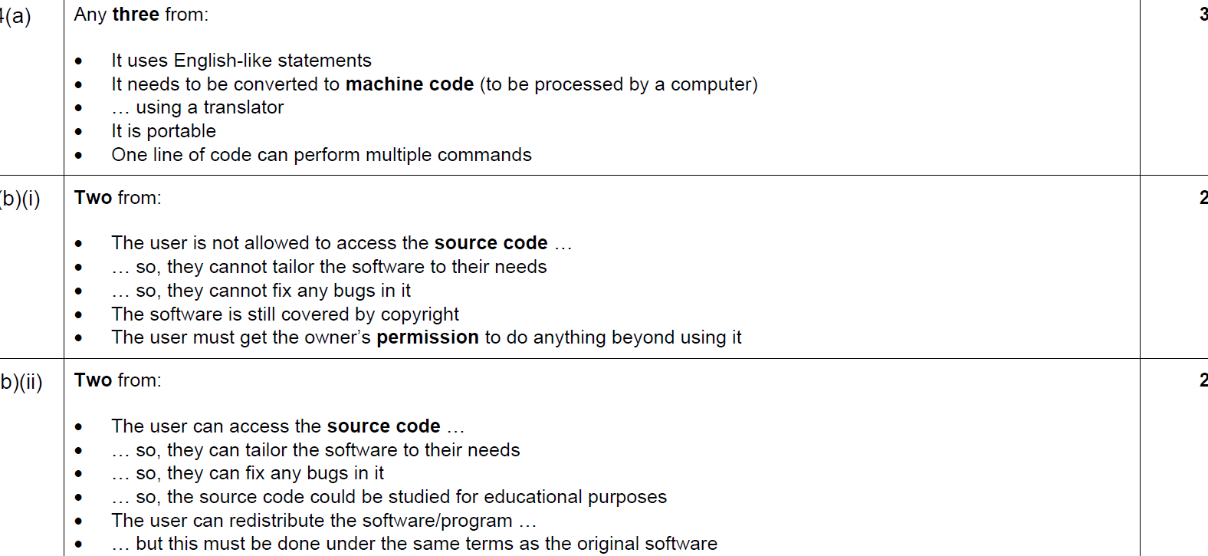
3. | 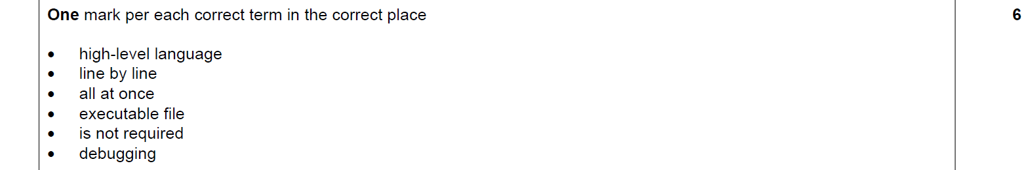
4. | All correct – 2 marks  At least 2 correct – 1 mark  Less then 2 correct – 0 mark  