**QUIZ 6 (GRADED)**

**POTENTIAL HEALTH RELATED PROBLEMS**

1. There are a number of health and safety issues associated with the use of computers.

Draw arrows from the terms Health or Safety to the matching issue. Use a maximum of four arrows. [4]

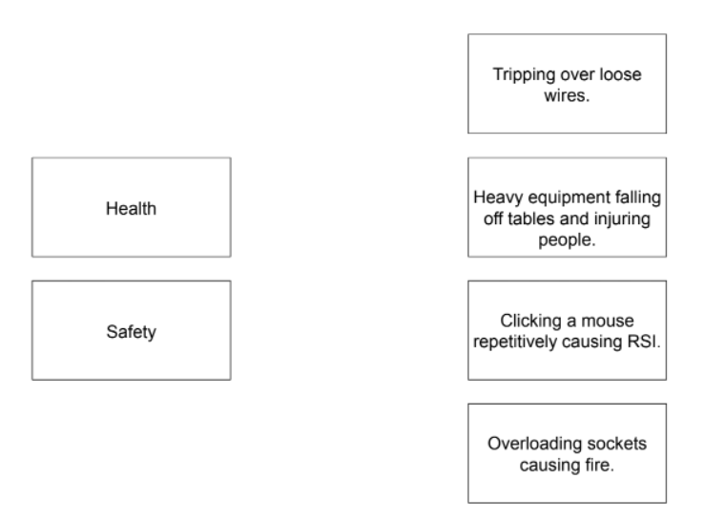

1. I) Explain what is meant by the abbreviation RSI [1]

………………………………………………………………………………………………………………………………………….

II) Describe how using a computer can cause RSI [1]

………………………………………………………………………………………………………………………………………….

………………………………………………………………………………………………………………………………………….

III)Describe two steps that can be taken to minimise the likelihood of developing RSI [2]

I………………………………………………………………………………………………………………………………………….

……………………………………………………………………………………………………………………………………………

II………………………………………………………………………………………………………………………………………….

…………………………………………………………………………………………………………………………………………...

IV)Other than RSI , describe two other health problems that may develop when using computers. [2]

I………………………………………………………………………………………………………………………………………….

………………………………………………………………………………………………………………………………………….

II………………………………………………………………………………………………………………………………………….

………………………………………………………………………………………………………………………………………….