QUIZ 8 Marking Scheme
POTENTIAL HEALTH RELATED PROBLEMS
1 | 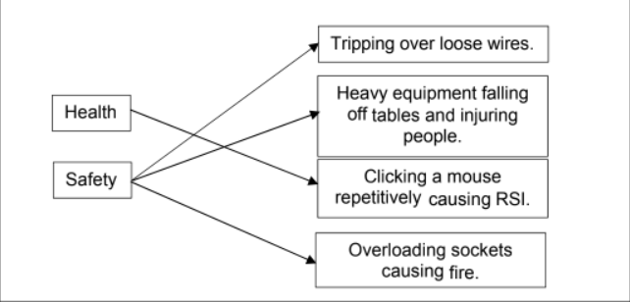 | 4
2i  ii  iii  iv | Repetitive strain injury  Using the same muscles in hands/arms for long periods without a break can cause RSI  Take regular breaks  Use an ergonomic mouse/wrist rest /copy holder  Back/neck ache  Eye strain / headaches | 1  1  2  2

