1.Rearrange the steps in the project plan if its out of order.

1.Requirement

2.Implementation

3.Design

4.Evaluation

5.Testing

________________________________________________________________

________________________________________________________________

________________________________________________________________

________________________________________________________________

________________________________________________________________

2.Create a project plan on calculator prototype that can add numbers. Each phases of the project must be explained briefly.

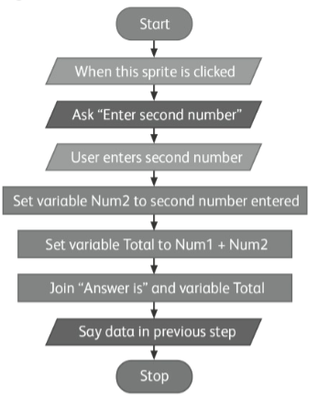

1. ________________________________________________________________

__________________________________________________________________

__________________________________________________________________

2. ________________________________________________________________

__________________________________________________________________

__________________________________________________________________

3. ________________________________________________________________

__________________________________________________________________

__________________________________________________________________

4. ________________________________________________________________

__________________________________________________________________

__________________________________________________________________

5. ________________________________________________________________

__________________________________________________________________

__________________________________________________________________