QUIZ-7
Document Production(Marking Scheme)

Sl.No | Answers | Marks
1. | 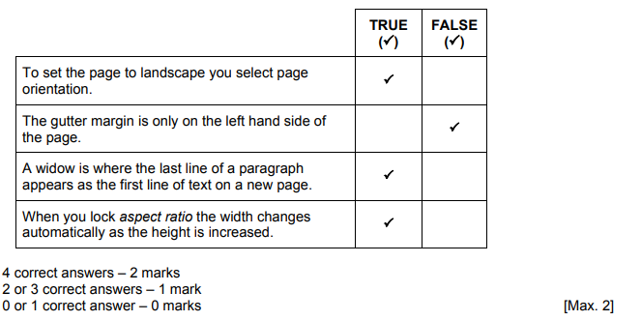 | 2
2 | 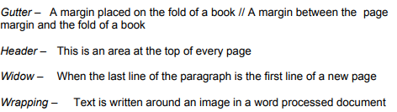 | 4
3 | 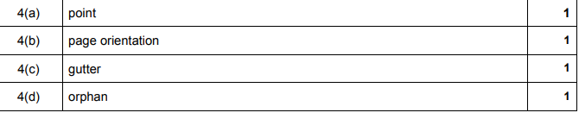 | 1  1  1  1

