**QUIZ-7**

**Document Production (GRADED)**

1. Tick whether the following statements are true or false, when word processing a document.

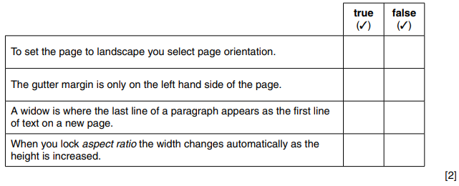

1. Explain the meaning of the following terms used in document production.

Gutter............................................................................................................................................... ........................................................................................................................................................Header...................................................................................................................................................................................................................................................................................................... Widow....................................................................................................................................................................................................................................................................................................... Wrapping...............................................................................................................................................................................................................................................................................................[4]

1. Different terms are used in document production.

Complete the following sentences.

1. The unit used to measure the size of a font is called

……………………………………………………………………………………………………………[1]

1. A page can be portrait or landscape. This is called

……………………………………………………………………………………………………………[1]

1. The special margin that is placed at the top or edge to clear the text from the fold in a page is called

……………………………………………………………………………………………………………[1]

1. When the first line of a paragraph appears as the last line of a page this is called.

……………………………………………………………………………………………………………[1]