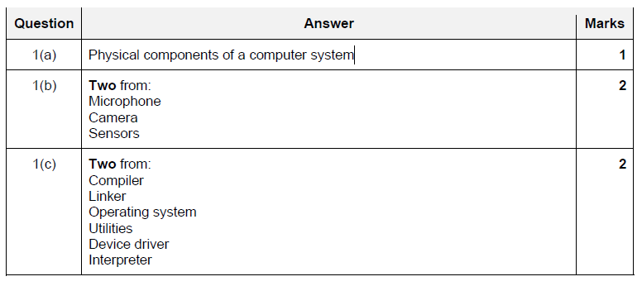

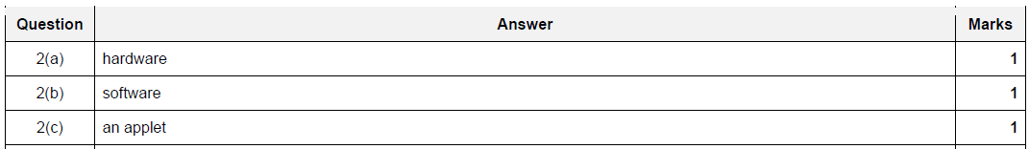

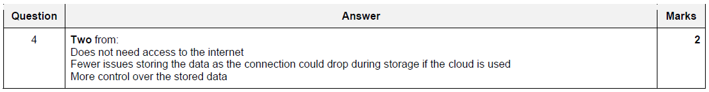

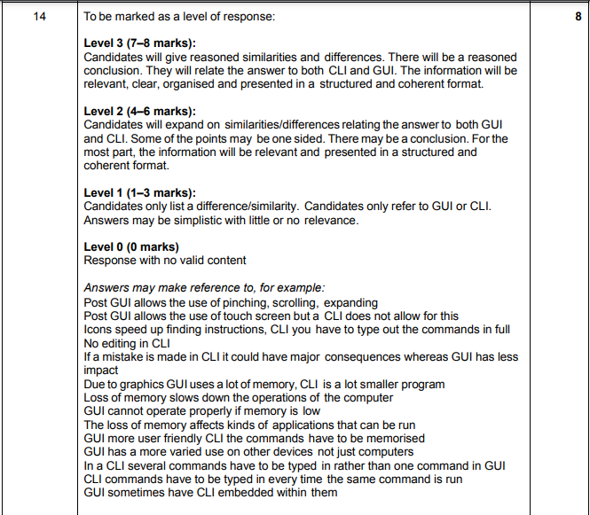





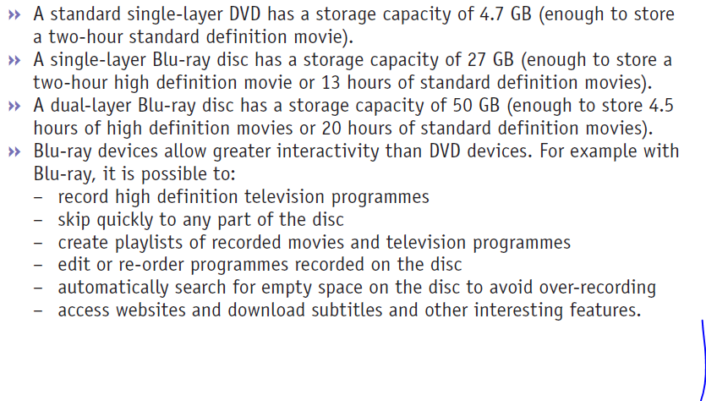**Question 7: Any Three Points from: 3**



Any Video Editing Software, Gaming Software uses SSD

Operating System, software programs and other files



**SSD HDD**

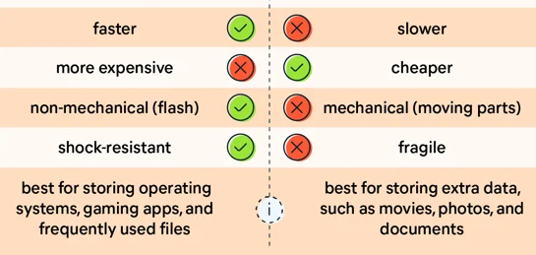



**Pot Player, GoM Player, VLC media Player use DVD**

PowerDVD is a Blu-ray player app that helps you to play high-quality video.