Quiz 2
Topic: Data Representation

1 a) A camera detector has an array of 4096 by 2048 pixels and uses a colour depth of 16. Calculate the size of an image taken by this camera; give your answer in MiB.

[5]

Question 2

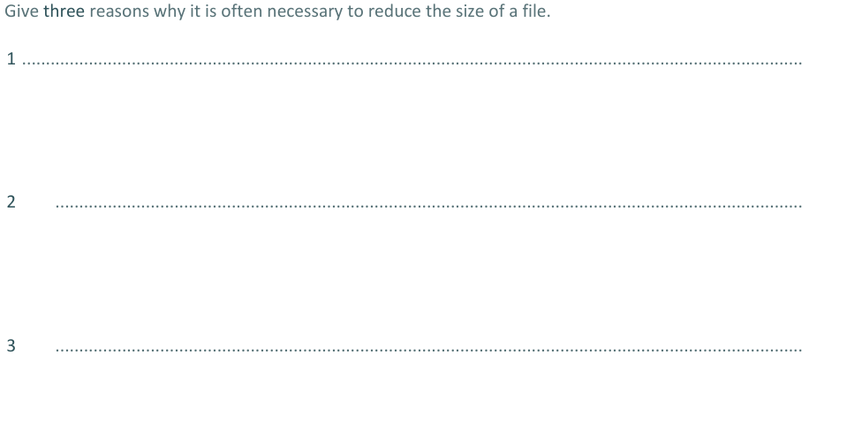
[3]
Question 3

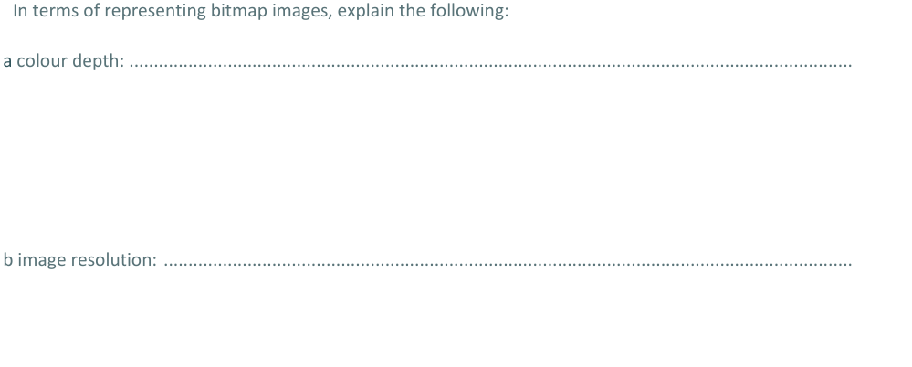
[2]

