**Chapter 3: Opportunities, risk , legal and ethical considerations**.

**Analyzing and managing risk**

**Starter activity:**

**After reading resource book page 65, list down various rewards undertaking an enterprise:**

**……………………………………………………………………………………………………………………………………………………………….**

**……………………………………………………………………………………………………………………………………………………………….**

**……………………………………………………………………………………………………………………………………………………………….**

**……………………………………………………………………………………………………………………………………………………………….**

**……………………………………………………………………………………………………………………………………………………………….**

**……………………………………………………………………………………………………………………………………………………………….**

**……………………………………………………………………………………………………………………………………………………………….**

**Development activity:**

**Answers to activity 3.3 course book page 42**

**……………………………………………………………………………………………………………………………………………………………….**

**……………………………………………………………………………………………………………………………………………………………….**

**……………………………………………………………………………………………………………………………………………………………….**

**……………………………………………………………………………………………………………………………………………………………….**

**……………………………………………………………………………………………………………………………………………………………….**

**……………………………………………………………………………………………………………………………………………………………….**

**……………………………………………………………………………………………………………………………………………………………….**

**……………………………………………………………………………………………………………………………………………………………….**

**……………………………………………………………………………………………………………………………………………………………….**

**……………………………………………………………………………………………………………………………………………………………….**

**……………………………………………………………………………………………………………………………………………………………….**

**Support notes:**

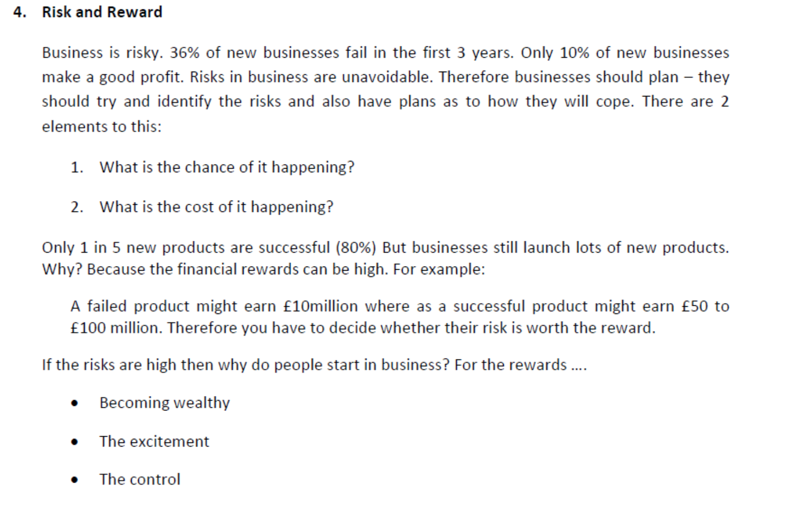

**Practice Activity:**

|  |  |
| --- | --- |
| **Key term** | **definition** |
| risk-keen |  |
| risk optimizers |  |
| risk reducers |  |
| risk averse |  |

**Now read the case study on course book page 43 and answer the question :**

**……………………………………………………………………………………………………………………………………………………………….**

**……………………………………………………………………………………………………………………………………………………………….**

**……………………………………………………………………………………………………………………………………………………………….**

**……………………………………………………………………………………………………………………………………………………………….**

**……………………………………………………………………………………………………………………………………………………………….**

**……………………………………………………………………………………………………………………………………………………………….**

**……………………………………………………………………………………………………………………………………………………………….**

**……………………………………………………………………………………………………………………………………………………………….**

**……………………………………………………………………………………………………………………………………………………………….**

**……………………………………………………………………………………………………………………………………………………………….**

**……………………………………………………………………………………………………………………………………………………………….**

**……………………………………………………………………………………………………………………………………………………………….**

**……………………………………………………………………………………………………………………………………………………………….**

**……………………………………………………………………………………………………………………………………………………………….**