MARKING SCHEME
SECTION A
1a  b | LCD Monitor  Laser printer  DVD RAM drive  Blu-ray disc drive | 2  2
2 | 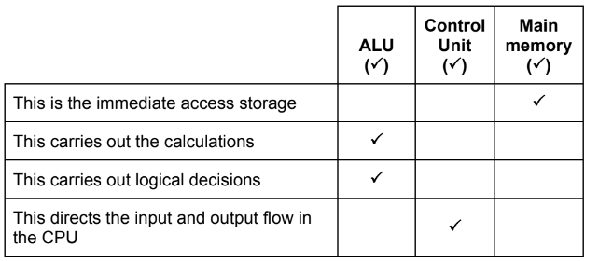 | 4
3 a  b  c | ROM/Read Only Memory  3D Printer  Sensor | 1  1  1
4 a  b | 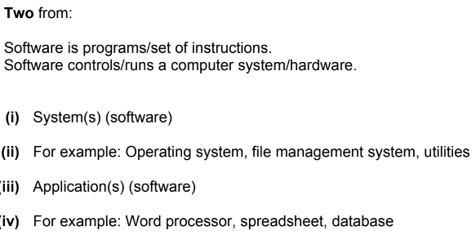 | 2  1  1  1  1
5a | 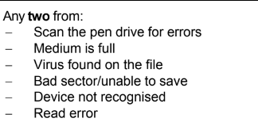 | 2
6 | 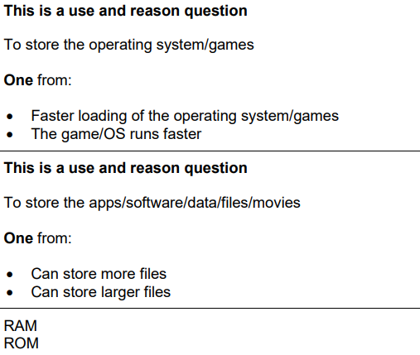 | 2  2  2
7 | 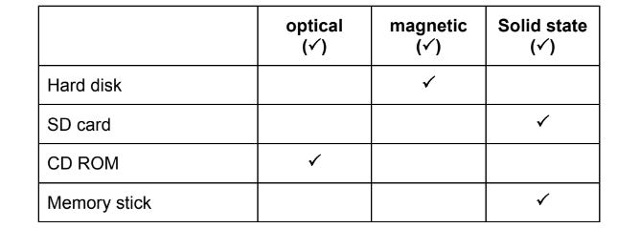 | 4
8 | 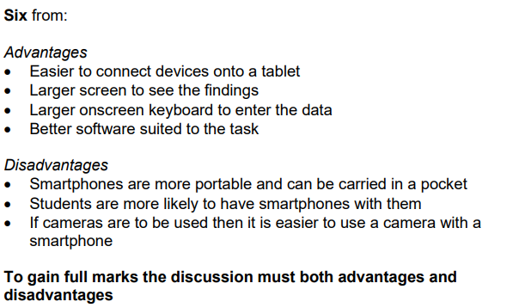 | 6
9 | 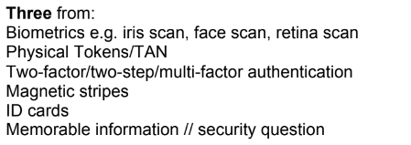 | 3

SECTION B

10 (a)  (b)  (c) | A bridge  A modem  A switch  A network interface card  They are in this order  All answers must be different  Routing table  Five from:  Data is sent in data packets//uses data packets.  Each data packet contains an IP address of the next router.  The router reads/checks/inspects the IP address.  It checks the IP address against its routing table.  Data packet is sent to the router with the IP address.  The router uses the IP address to work out the best route/destination  Computer.  The router stores the IP addresses. | 4  1  5
11 | Four from:  With a CLI Instructions must be typed to get a computer to carry out an  action  The user needs to remember/learn/understand the commands in a CLI  The instructions need to be entered correctly in CLI  With a CLI you have to remember the exact path and name of application  With a CLI it is more important that users understand how a computer works  With a GUI you just click on an icon  In the GUI the instructions are pre-determined  GUI is more user-friendly  GUI uses more processing power  GUI uses more memory | 4
12 a  b | 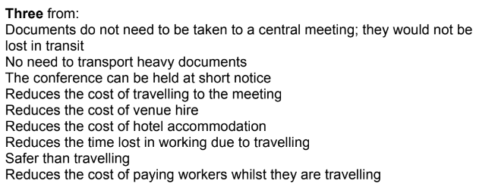  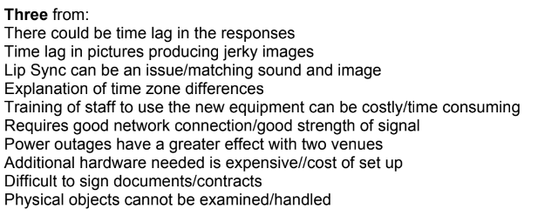 | 3  3
13 | 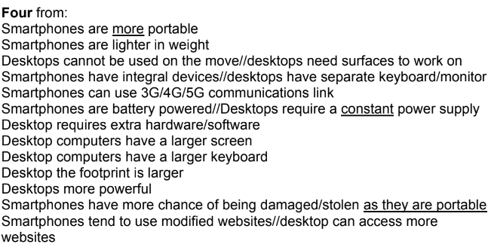 | 4

SECTION – C
14 | 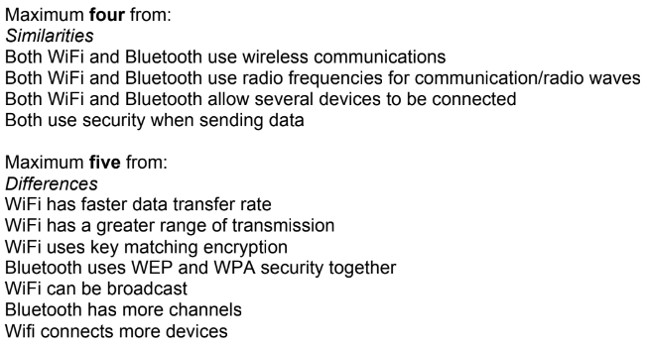 | 6
15 | 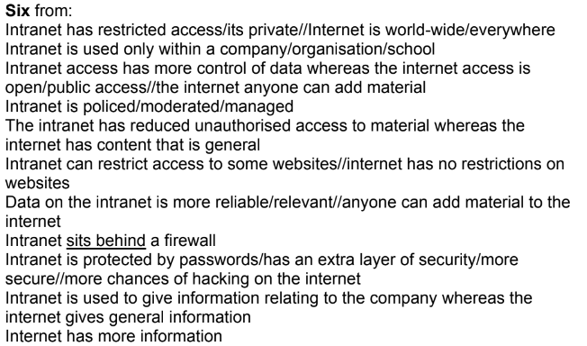 | 6
16 | 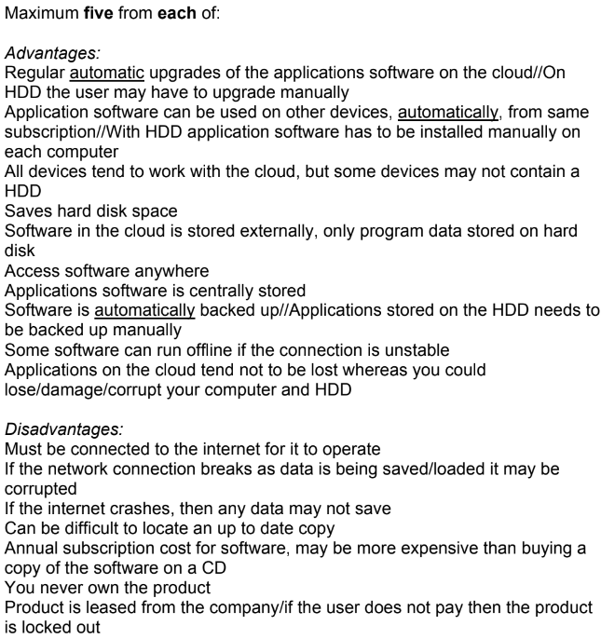 | 6

