**Chapter 3: Opportunities, risk , legal and ethical considerations**

**McDonald’s SWOT Analysis 2022**

MAR 3, 2022 BY [ABDUL MOMIN](https://pestleanalysis.com/author/amomin/)

There are certain brands in this world that are so widespread and popular, that they have in one way become an essential part of our lives. McDonald’s is one such business. How have they become such a big influence when there are so many other places that sell fast food? We will try and figure this out in this **McDonald’s SWOT Analysis** [since we have already conducted a PEST analysis](https://pestleanalysis.com/pest-analysis-of-mcdonalds/) on the fast-food brand.

I’m going to take the chance of assuming that all of you who stumble upon this article have had McDonald’s multiple times in your lives. Granted, there are so many more variants in the world but this company has managed to not only persist but to grow all across the globe.

Even if McDonald’s is not your go-to choice for a quick bite, you have to agree that their fries are just out of this world spectacular in taste. They also have amazing soft-serve ice cream. Depending on what country you live in, they also offer so many things unique to specific regions.

A[SWOT analysis](https://pestleanalysis.com/swot-analysis-definition/) will enable us to understand thoroughly how McDonald’s has achieved such success. Before we move on ahead though, we should look at the SWOT in a bit more detail.

You see, in a basic[SWOT template](https://pestleanalysis.com/swot-analysis-template/), you have a collection of four factors that govern the state of the entity being analyzed, a company in this case. These are strengths, weaknesses, opportunities, and threats.

The strengths and weaknesses of this framework are called the internal factors of the organization. These are the factors that can be influenced by the company under consideration. For example, if McDonald’s has a huge brand name, this is a strength for the company.

It is a strength because of all the hard work the company has put in to make it possible, so it is an internal factor. Threats and opportunities, on the other hand, are external factors. These factors as opposed to the former ones are out of the influence of the organization and occur irrespective of their will.

McDonald’s can venture out into other forms of businesses to grow as a form of finding opportunities; an example of why this is an externally motivating factor. Now that you know how SWOT works in a basic manner, we can move on.

Even if you prefer Burger King over McDonald’s, it can’t hurt to study the brand using the[SWOT table](https://pestleanalysis.com/swot-table/). Let’s see how it applies to the brand.

[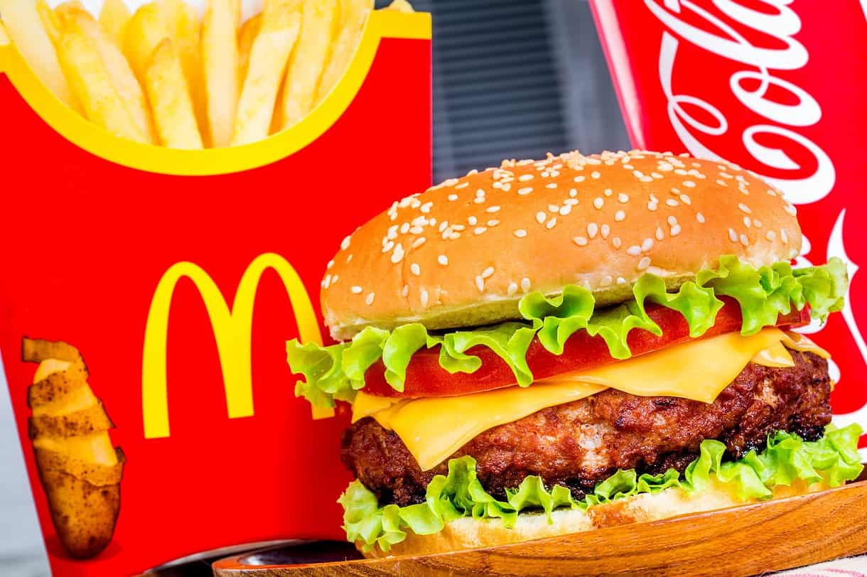](https://pestleanalysis.com/wp-content/uploads/2015/10/mcdonalds-swot-analysis-opportunities.jpg)

**Contents**

* [What are some of the biggest strengths McDonald’s has?](https://pestleanalysis.com/mcdonalds-swot-analysis/#What_are_some_of_the_biggest_strengths_McDonalds_has)
  + [Global Presence](https://pestleanalysis.com/mcdonalds-swot-analysis/#Global_Presence)
  + [Brand Equity](https://pestleanalysis.com/mcdonalds-swot-analysis/#Brand_Equity)
  + [Transnational Expansion](https://pestleanalysis.com/mcdonalds-swot-analysis/#Transnational_Expansion)
  + [Technologically Sound](https://pestleanalysis.com/mcdonalds-swot-analysis/#Technologically_Sound)
  + [Market Share](https://pestleanalysis.com/mcdonalds-swot-analysis/#Market_Share)
* [What are some of the biggest weaknesses McDonald’s currently has?](https://pestleanalysis.com/mcdonalds-swot-analysis/#What_are_some_of_the_biggest_weaknesses_McDonalds_currently_has)
  + [Their Food](https://pestleanalysis.com/mcdonalds-swot-analysis/#Their_Food)
  + [The Business Model](https://pestleanalysis.com/mcdonalds-swot-analysis/#The_Business_Model)
  + [Employee Dissatisfaction](https://pestleanalysis.com/mcdonalds-swot-analysis/#Employee_Dissatisfaction)
  + [The Menu Doesn’t Have Many Options](https://pestleanalysis.com/mcdonalds-swot-analysis/#The_Menu_Doesnt_Have_Many_Options)
* [What are some of the biggest Opportunities McDonald’s can go for?](https://pestleanalysis.com/mcdonalds-swot-analysis/#What_are_some_of_the_biggest_Opportunities_McDonalds_can_go_for)
  + [Menu Expansion](https://pestleanalysis.com/mcdonalds-swot-analysis/#Menu_Expansion)
  + [Expansion](https://pestleanalysis.com/mcdonalds-swot-analysis/#Expansion)
* [What are some of the biggest threats McDonald’s should be working to avoid?](https://pestleanalysis.com/mcdonalds-swot-analysis/#What_are_some_of_the_biggest_threats_McDonalds_should_be_working_to_avoid)
  + [Competition](https://pestleanalysis.com/mcdonalds-swot-analysis/#Competition)
  + [Emerging Consumer Tastes and Preferences](https://pestleanalysis.com/mcdonalds-swot-analysis/#Emerging_Consumer_Tastes_and_Preferences)
* [McDonald’s SWOT Analysis: Final Thoughts](https://pestleanalysis.com/mcdonalds-swot-analysis/#McDonalds_SWOT_Analysis_Final_Thoughts)

**What are some of the biggest strengths McDonald’s has?**

Strengths are usually the easy factors to consider because not only are they very obvious, they are very exciting to talk about as well because this is how a company sets itself apart from all other competitors. Here are some of the biggest strengths McDonald’s currently can boast.

**Global Presence**

There are hardly any countries in the world that don’t have a local McDonald’s chain in their vicinity. Currently, there are over[120 countries](https://worldpopulationreview.com/country-rankings/countries-without-mcdonalds) in the world that have McDonald’s. Pretty impressive for a brand to be able to achieve such success!

**Brand Equity**

McDonald’s has some of the best branding practices. Their marketing efforts have paid off because as soon as you see those wonderful golden arches, you instantly know what to think of.

Their logo is recognized by everyone in the world and even their staple food items such as their fries and the all-mighty Big Mac are easy to spot.

**Transnational Expansion**

It is one thing for a brand to be global, it is another for the same brand to be locally adaptive. Very few companies are able to achieve both successfully.

McDonald’s has mastered the art of formulating a transnational strategy of entering into other countries. They have a franchising model of business which makes it possible for all of their chains to be sensitive to the cultural and traditional requirements of the countries they operate in.

For example, McDonald’s in India also offers vegetarian options on the menu which aren’t available anywhere else. This strategy has made it very easy for McDonald’s to become a success in so many regions around the globe.

**Technologically Sound**

McDonald’s has successfully adapted with the times to be very aware of technological advancements in the world.

They offer a lot of innovative solutions to customers globally. Their self-service kiosks make it possible for customers to not only select their order but also to pay for it without getting into queues.

Moreover, their delivery time in the drive-through portions also is very impressive. In 2021, they formed a[strategic partnership](https://www.cnbc.com/2021/10/27/mcdonalds-enters-strategic-partnership-with-ibm-to-automate-drive-thru-lanes.html) with IBM to develop technology enabling the drive-through to be automated.

**Market Share**

They have the highest market share when it comes to the fast-food industry. This isn’t too hard to believe because we already know that they are literally everywhere in the world.

As of February of 2022, they have a[market cap](https://companiesmarketcap.com/mcdonald/marketcap/) of $186.40 Billion! It is because of this achievement they are currently one of the world’s most valuable organizations.

[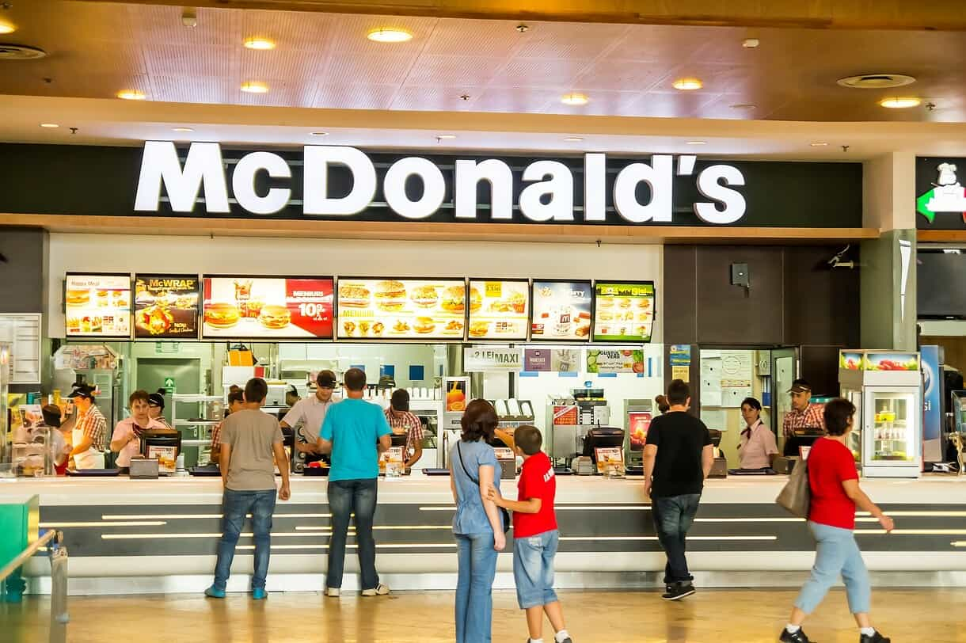](https://pestleanalysis.com/wp-content/uploads/2015/10/mcdonalds-swot-analysis-strengths.jpg)

**What are some of the biggest weaknesses McDonald’s currently has?**

No matter how successful a brand may appear to be, they always have certain weaknesses that humble them down or rather motivate them to be even better. Here are some of the current weaknesses the brand should be mindful of.

**Their Food**

Whilst people love to eat McDonald’s and they enjoy the taste as well, it is still an undeniable fact that fast food is very bad for health.

This type of food only gives consumers excess calories and no actual nutritional value. Since McDonald’s has the biggest chunk of the market share, they are automatically the biggest contributors to obesity in people, especially children and teenagers who have a greater love for fast food.

**The Business Model**

Whereas the franchising strategy has helped them spread around the world in so many countries, it also has downsides.

It makes it very difficult for business owners to keep a check on how operations are being conducted when they sell to franchisees. The degree of standardization in terms of quality and the overall brand experience is also compromised.

So this is why in some countries, people love McDonald’s whereas in others the brand does not do exceptionally well.

Even in certain regions of the same country, some franchises are better in service and in quality than others. This is a big flaw with the franchising business model.

**Employee Dissatisfaction**

Employees in the company’s franchises have been known to not be satisfied with their wages over the years.

They believe the number of hours they put into work is not being rewarded adequately. Because franchisees are independently owned and most of them are not owned by the company itself, wages also vary.

As a result of this backlash, McDonald’s has decided to eradicate the wage issue in all of their restaurants by the year[2024](https://www.cnbc.com/2021/07/10/mcdonalds-minimum-wage-raise-and-the-fast-food-franchise-future-.html). This tells us that there is still a lot of time before employees are happy with their wages and not to think that even more people will have been employed by then.

**The Menu Doesn’t Have Many Options**

For a fast-food lover, the menu is perfect. But for people who like to indulge with healthier snacking options, McDonald’s, unfortunately, serves nothing.

They should include more options in their menu as well.

**What are some of the biggest Opportunities McDonald’s can go for?**

As in any other[SWOT example](https://pestleanalysis.com/swot-analysis-examples/), McDonald’s still has many opportunities they can capitalize on to grow even bigger and stronger as a brand. We are going to address some of the most promising ones here.

**Menu Expansion**

One of the weaknesses they currently are facing can easily be terminated by taking this opportunity. McDonald’s is all about food as a brand; they have countless options to include in their menus all around the globe.

The biggest trend that they can take advantage of is healthy eating alternatives. They should have options for people who are wary of what they consume either for weight loss or just for a better lifestyle.

They can also introduce organic and fresh varieties of their food for those people who only consume organic.

**Expansion**

They are currently in more than 120 countries. Their goal can be to be in all of them on earth. The franchising model has worked splendidly for them up till now as far as expansion is concerned.

However, [they can look at other business models](https://pestleanalysis.com/business-model/) to fix the quality assurance problem at hand as well.

[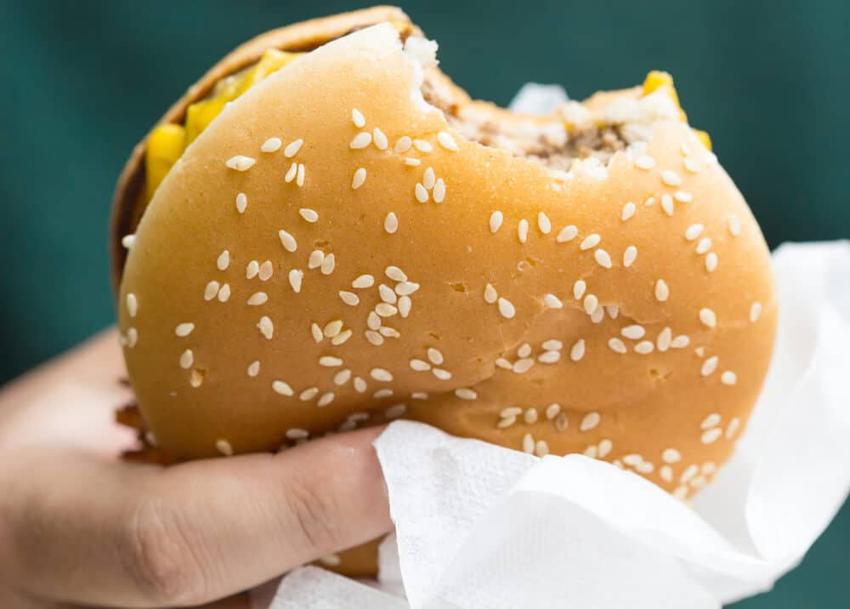](https://pestleanalysis.com/wp-content/uploads/2015/10/mcdonalds-swot-analysis-strengths-threats.jpg)

**What are some of the biggest threats McDonald’s should be working to avoid?**

Like any other company, threats exist for McDonald’s as well. Threats should never be taken lightly by any brand and they should be neutralized or mitigated as soon as possible so that there is very little irreversible damage done. Here are some of the biggest ones in this case.

**Competition**

Yes, McDonald’s currently is the market leader in the fast-food industry because they are ahead of all of their competition. This certainly doesn’t mean that competition should be ignored or worse, underestimated.

Although McDonald’s is very successful on their own, they still have many competitors to give them a tough time.

Two of their biggest direct competitors are[Burger King](https://pestleanalysis.com/swot-analysis-of-burger-king-is-the-fast-food-industry-saturated/) and Wendy’s. They are always engaged in marketing wars with each other because all 3 places serve fast food consisting mainly of fries and burgers.

If we venture out into the indirect competition,[KFC](https://pestleanalysis.com/swot-analysis-of-kfc/) is also a rival brand because fried chicken also falls into the fast-food category. Speaking of fast food,[Chipotle](https://pestleanalysis.com/chipotle-swot-analysis/) is also very popular with people and they also serve Mexican fast food to customers.

These are only some prominent mentions; there are thousands of smaller and local fast food and burger chains all across the world which also offer the same category of food.

**Emerging Consumer Tastes and Preferences**

Consumer trends are the driving force of every business’s life cycle. The ones that learn to evolve with the trends continue to survive, whereas others become obsolete.

As we know, many people are leaning towards clean and healthy eating to have a better quality of life. How long will fast-food chains survive in the market if more and more people choose to move away from junk food towards cleaner alternatives?

McDonald’s should be very careful because, in the matter of the upcoming decade, things might be very different for the brand and their actual need in the market.

**McDonald’s SWOT Analysis: Final Thoughts**

If you have completed your reading journey through this article, we are going to say you now know more than you did before about McDonald’s.

Not only that, you also know[how to conduct a SWOT](https://pestleanalysis.com/how-to-do-a-swot-analysis/) in a simple and precise manner. Based on what has been compiled in the article above, it can easily be seen that their strengths are far heavier than all other factors.

They do have a few weaknesses that should be dealt with soon but as can be read, there are opportunities to get rid of those weaknesses.

The threats are a bit serious especially if consumer trends change over time, however, if we can see anything from their journey so far, it’s that McDonald’s isn’t going anywhere any time soon. We have a lot more to see from the brand.