**Chapter 3: Opportunities, risk , legal and ethical considerations**

**Starter activity:**

Make a mind map of all the various ways business opportunities may arise.

**Development activity:**

In the space given below, mention briefly how Robin and Gerard from the case study given below, were able to take advantage of the gap in the market.

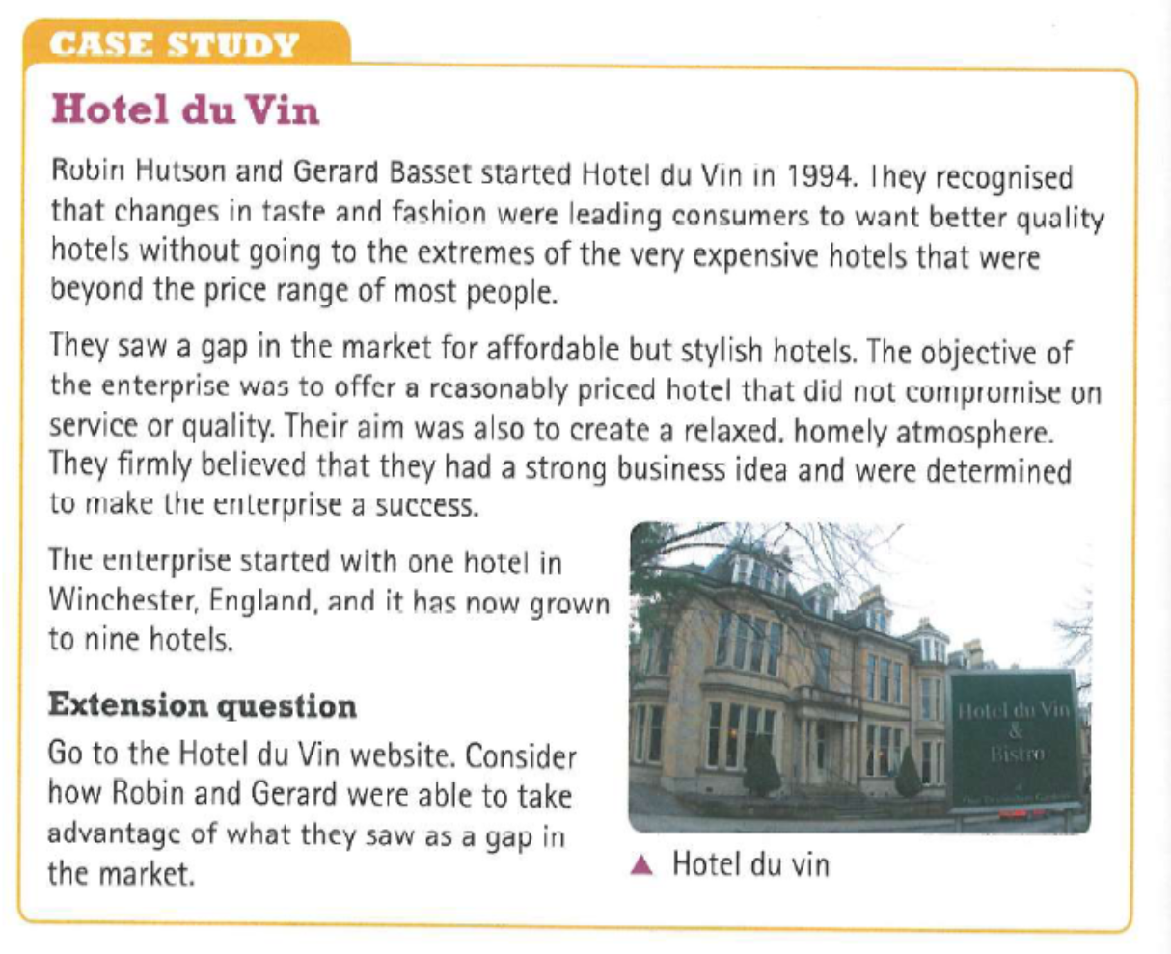

**……………………………………………………………………………………………………………………………………………………………….**

**……………………………………………………………………………………………………………………………………………………………….**

**……………………………………………………………………………………………………………………………………………………………….**

**……………………………………………………………………………………………………………………………………………………………….**

**……………………………………………………………………………………………………………………………………………………………….**

**……………………………………………………………………………………………………………………………………………………………….**

**……………………………………………………………………………………………………………………………………………………………….**

**……………………………………………………………………………………………………………………………………………………………….**

**……………………………………………………………………………………………………………………………………………………………….**

**……………………………………………………………………………………………………………………………………………………………….**

**……………………………………………………………………………………………………………………………………………………………….**

**Support notes:**

**Spotting an Opportunity**

|  |  |
| --- | --- |
| **Opportunity** | **Explanation** |
| Need or demand | If there is a need for something or demand then this can lead to an opportunity for a business. For example there is demand for products which make consumers lives easier. This has meant that food manufacturers have created convenience food which can be cooked quickly to meet this demand. |
| New technology | The internet has led to lots of new opportunities. For example downloading music has nearly replaced the need for CD’s. Also banks have seen opportunity to develop online banking to appeal to their customers. |
| Research and Development | Did you know that the Dyson Vacuum was created after lots of research and development? The inventor James Dyson thought conventional vacuums didn’t work very well so he spent years researching ways to make them better before he came up with the Dyson. |
| Expansion | If an area grows or expands this could lead to new opportunities. For example if a new block of apartments is created then companies like maids or take-away delivery companies may see an opportunity to gain more customers. |
| Changes in tastes and fashions | Peoples likes and dislikes change all the time. Therefore knowing what the next ‘must have’ item is can help a business identify an opportunity before its competitors. For example a popular trend at the moment is ‘healthy eating’ – this has led to lots of opportunities for businesses to create healthy foods to get more customers. |
| Change in population and size | Changes in the make-up of the population can lead to opportunities for enterprises. For example, did you know that the population is living longer? This means that there are opportunities for businesses targeting the older generation. |
| Changes in real income | If the money people earns changes this could lead to new opportunities for a business. For example during the ‘global’ recession many budget supermarkets saw an opportunity to gain more customers by offering lower prices for people who were earning less money. |
| Globalisation | It is now much easier to trade around the world. Travel and communication has improved which makes it easier for businesses to move into new markets. Take Dubai for example – many foreign businesses have come here after seeing an opportunity to gain more customers as the area grows. |
| Government Policies | If the government introduces a new polices or a new set of laws then this could lead to new opportunities. For example in the UK smoking in public buildings was banned – this meant that copies that made outdoor heaters saw an opportunity to provide outdoor smoking shelters. |

**Practice Activity:**

Read the case study given and answer the extension questions in the space given below:











































