**Research Resource**

**Chapter 4 Operating Systems and Computer Architecture**

**Introduction and Operating Systems**

**In this world, technology is developing quick. Computers, Laptops, Mobile phones, and all sorts of stuff, they need an operating system so they can function. The operating system makes it possible to communicate with the software and hardware. It also manages basic functions such as: Input and output control, Multitasking and Multi-programming, Security, etc. The most common operating systems (OS) are: Windows, Linux, Mac OS. For mobile phones : iOS, Android, Windows, Blackberry OS.**

**When a computer turns up, all the initiated programs are loaded into the memory, from the ROM (Read Only Memory). Then, the programs run a security check, and make sure that the hardware, processor, internal memory and BIOS (basic input-output system) are all functioning correctly, and if everything is fine, the OS will load up.**

**Interrupts and Buffers**

**Buffer: A buffer is a temporary storage area, and its mainly located in the RAM. The CPU can use the data or manipulate it before sending it to another device. Once the information is passed over, the information in the RAM is deleted.**

**Interrupts: A interrupt is a signal sent from a device or software to the processor. This will cause the processor to temporarily stop what it is doing and service the interrupt. An interrupt handler takes into account all of these signals and prioritizes them in a queue in order to figure out which one to deal with first.**

**Von Neumann Model**

**There are 10 components which make up the Von Neumann model as well as different buses that are used to connecting components to one another. There are benefits of using the Von Neumann Model but as an IGCSE student, you need to be able to recall the advantages of using this model and be able to draw and describe how components are connected/how data is transmitted.**

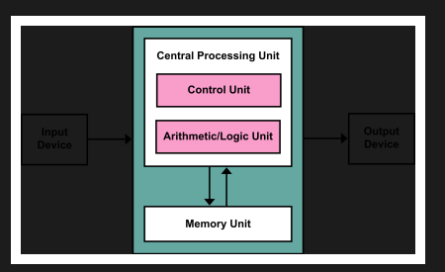

**The von Neumann model was developed by John von Neumann in 1945. Models prior to this could only carry out one task. Prior systems would need to be rebuilt to carry out multiple tasks. The von Neumann model proved easier to reprogram than other systems.**

**Von Neumann model was developed by John Von Neumann in 1945, Models prior to this could only carry out one task.This model allows computers to store information since before the model was designed, computers could not store information without human assistance. This contains 3 main components, CU (Control Units),ALU (Arithmetic Logic Unit) and MU(Memory Unit). The CU contains the PC (Program Counter) and the CIR (Current Instruction Register) and the Memory Unit contains MAR and the MDR(Memory Address Register and Memory Data Register), 1st the CU fetches the instructions and the address is copied from the PC to the MAR. Then the instruction is copied from MAR to the MDR. The contents of the MDR is copied into the CIR,PC incremented by 1 and next instruction is fetched, Instruction is decoded then executed using the control bus.**

**Cache memory – used for high speed storage**

**Register – holds data or instructions during processing**

**Accumulator- register that is used for calculations**

