**Task A:**

1. Open a new project.

2. Add any Background.

3. Add the Fish character.

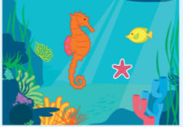

4. Create a program for the Fish to match this algorithm.

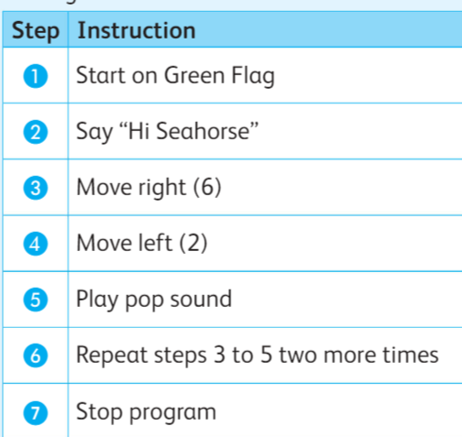

5. Run your code.

**Task B:** Create a poster about **Cyberbullying .**



1. Open MS Word.
2. Create a poster about **Cyberbullying.**
3. Apply any page border.
4. Apply any page colour.
5. Insert picture in the poster.
6. Save your poster as **Cyberbullying.**