**Homework:**

**Write a synonym for each given word.**

1. Happy: _______________________________________________
2. Smart: _______________________________________________
3. Calm: ________________________________________________
4. Large: _______________________________________________
5. Determined: __________________________________________
6. Famous: _____________________________________________
7. Beautiful: ____________________________________________
8. Angry: ______________________________________________
9. Explore: _____________________________________________
10. Kind: _______________________________________________

**Choose the correct synonym for each given words.**

1. Despite facing setbacks, Mark remained __________ and focused on achieving his goals.

A. Determined

B. Lazy

C. Careless

D. Forgetful

2. Art is known for her __________ personality, always ready to help others.

A. Kind

B. Angry

C. Sad

D. Rude

3. After the long hike, the hikers reached the __________ summit of the mountain.

A. Steep

B. Flat

C. Sharp

D. Peak

4. The novel was so __________ that it captivated readers from the beginning to the end.

A. Boring

B. Exciting

C. Dull

D. Tedious

5. The artist created an __________ painting that displayed a riot of colors.

A. Monochromatic

B. Dull

C. Vibrant

D. Pale

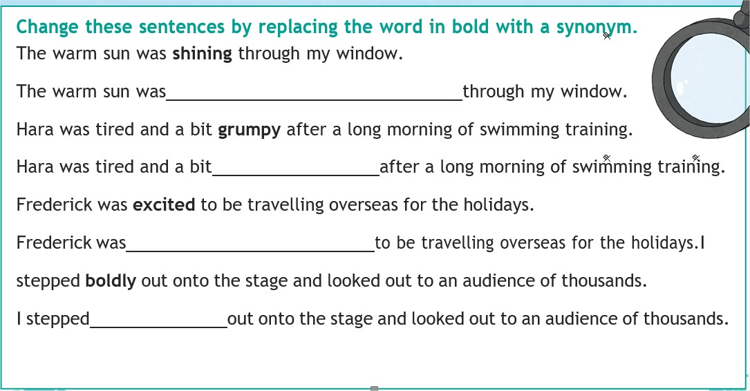

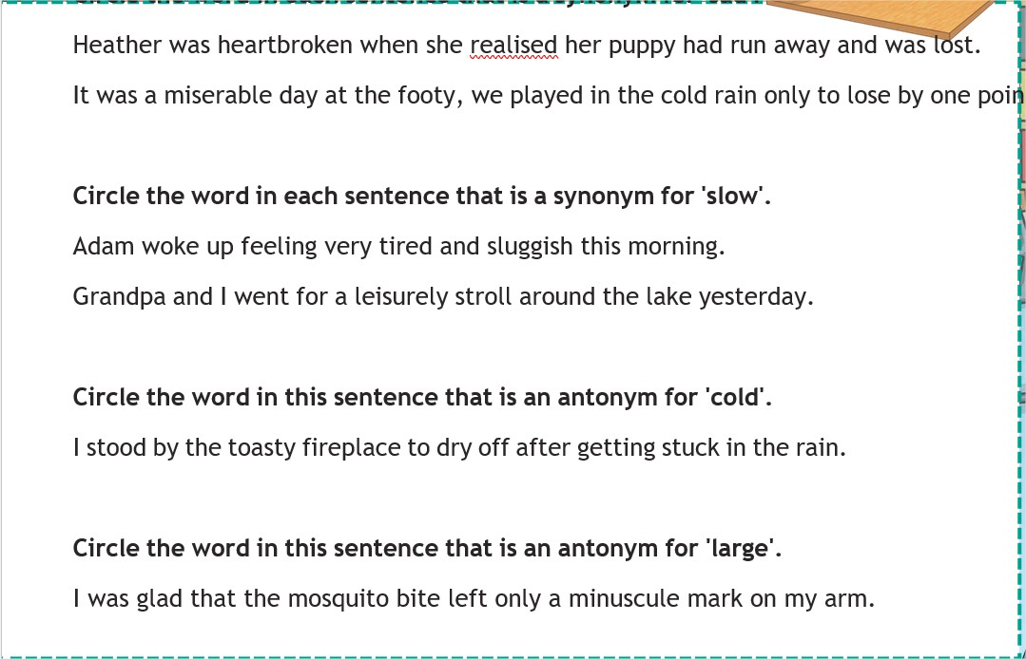

**Write your own sentences, using the synonyms of Challenging.**

**____________________________________________________________________________________________________________________________________________________________**

**Write your own sentences, using the synonyms of Perplex.**

**____________________________________________________________________________________________________________________________________________________________**