Exit ticket

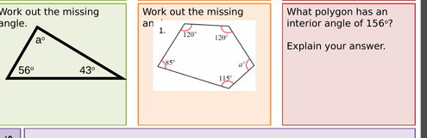

Exit ticket



Exit ticket

