**Programming**

1.Print "Hello World" if a is greater than b.

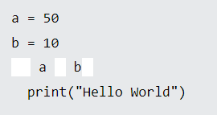

2. Print "Hello World" if a is not equal to b.

