1) Create the MakeCode program after decomposing the algorithm below.

a) When the micro:bit is shaken, it displays a random number between 1 to 6 on the LED display. This number is shown for 5 seconds and the screen clears.

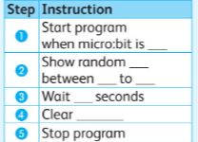

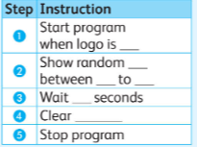 b) When the micro:bit logo is touched, it displays a random number between 2 to 12 on the LED display. This number is shown for 2 seconds and the screen clears.

i) Open new project.

ii) Create the code by following the above algorithm a and algorithm b.

iii) Run program.

|  |  |  |  |
| --- | --- | --- | --- |
| **Rubric for Makecode** | | | |
|  | 1 | 2 | 3 |
| Open project |  |  |  |
| Able to use basic block |  |  |  |
| Use of math block |  |  |  |
| Run the code |  |  |  |
| **Key**:   1. Needs more opportunity to develop this skill. 2. Beginning to demonstrate this skill. 3. Has achieved this skill. | | | |