**WORKSHEET**

1. Part of the spreadsheet is shown, column G subtracts the Forecast grade from the Average

grade.

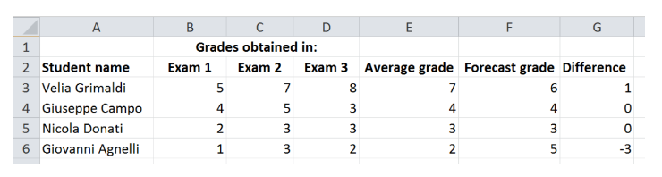

The teacher has typed a formula in cell E3. The formula is ROUNDUP(AVERAGE(B3:D3),0)

Explain, in detail, what the formula does.

……………………………………………………………………………………………………………………………………………………………………………………………………………………………………………………………………………………………………………………………………………………………………………………………………………………………………………………………[4]