MS-WORD

Microsoft Word is a word processor developed by Microsoft. It was first

released in 1983 under the name Multi-Tool Word for Xenix systems. MS

Word is a popular word-processing program used primarily for creating

documents such as letters, brochures, learning activities, tests, quizzes and

students' homework assignments. There are many simple but useful features

available in Microsoft Word to make it easier for study and work. That's why

so many people would prefer to convert the read-only PDF to editable Word

and edit PDF in Word.

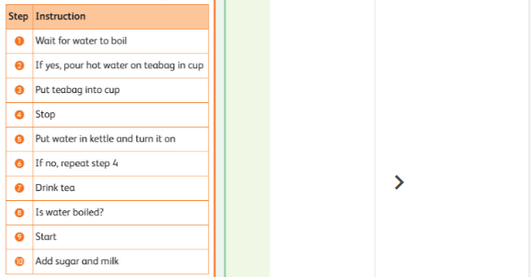﻿Look at the algorithm for making a cup of tea. The steps of the algorithm are in the wrong order. Put them in the right order and match each step of the algorithm to a flowchart symbol.

1.Using the flowchart, identify.

a.The inputs

_____________________________________________________________________

_____________________________________________________________________

b.The processes

_____________________________________________________________________

_____________________________________________________________________

c.The decision

_____________________________________________________________________

_____________________________________________________________________

2.Predict the possible outcomes of the flowchart.

_______________________________________________________________________

_______________________________________________________________________

______________________________________________________________________

_________________________________________________________________________

|  |  |  |  |  |
| --- | --- | --- | --- | --- |
| **Rubric for flowchart** | | | | |
|  | 1 | 2 | 3 | Total |
| Able to add the symbols |  |  |  |  |
| Able to complete the flowchart |  |  |  |  |
| Able to predict the outcome |  |  |  |  |
| **Key**:1. Needs more opportunity to develop this skill.  2.Beginning to demonstrate this skill.  3.Has achieved this skill. | | | | |